

**E-Project**

**Web Designing**

**OnlineBanking**

|  |  |
| --- | --- |
| **Authors** | **Aptech – C1908G2 - Group 4** |
| * HOANG MINH TIEN  Student1233606 (leader) * NGUYEN HOANG BICH  Student1233683 * VU THI THOM   Student1233668   * TRINH PHUONG NAM   Student1062609 |
| **Centre Name** | Aprotrain Aptech |
| **Date** | 28-Apr-2021 |
| **Semester** | 3 |
| **Instructor** | PHAN HUU TRI |

**Table of Content**

**Preface**

**Chapter 1 :** **Overview**

1. Introduce the topic:

2. Pages transition diagram

3. Purpose of the application:

**Chapter II : Tender requirement**

1. Functional requirement:

2. Non-Functional Requirement

**Chapter III: E-Project design**

1. DFD Design for eProject:

2. Database structure design for eProject

**Chapter IV: Interface snapshot**

1. parges for User:

2. parges for Admin:

**Chapter V: User guide**

1. Login page:
2. Forgot pasword page:
3. Sign up page:
4. Authentication page:
5. Home page:
6. Profile page:
7. Setting page:
8. Account page:
9. Transaction page:
10. Contact page:
11. User manual page:

**Chapter VI: Admin guide**

1. Home page:

2. Acount object:

3. Bank account:

4. Banks:

5. Curencies:

6. FAQ:

7. Customer questions:

8. Super admin

**Chapter VII : Developer guide**

**PREFACE**

Internet Banking is service E-banking used to query information Account and perform transaction conversions and payments via the Internet. Internet Banking allows customers to make online transactions without need a bank. Just a computer or mobile phone with a connection connect Internet and access code provided by the Bank, customers can do it perform transactions with the Bank anytime, anywhere in a secure way.

Internet-Banking service features: Transactions are done through the Internet, so it is highly dependent on technology, Depends on user level, Fast, convenient, save time and travel costs.

Benefits in the process of using Internet-banking.

- For the bank: Save costs, increase revenue. Expand the scope of activities, improve competitiveness. Increase the ability to care and attract customers.

- For customers: Convenient, save time. Cost savings. Fast, timely, efficient.

Through this, we would like to express our sincere thanks and express gratitude to the dedicated instructions of teachers in the school "Aptech international programmer training system". Especially Mr. PHAN HUU TRI, who directly instructed, taught and helped us during the implementation of this project.

**Chapter I: Overview**

* **Introduce the topic:**

Development of a safe and secure Internet banking system.

* **Pages transition diagram:**
* For user:

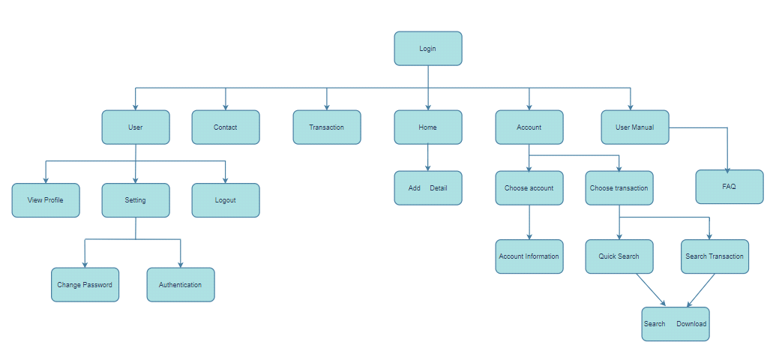

* For admin:

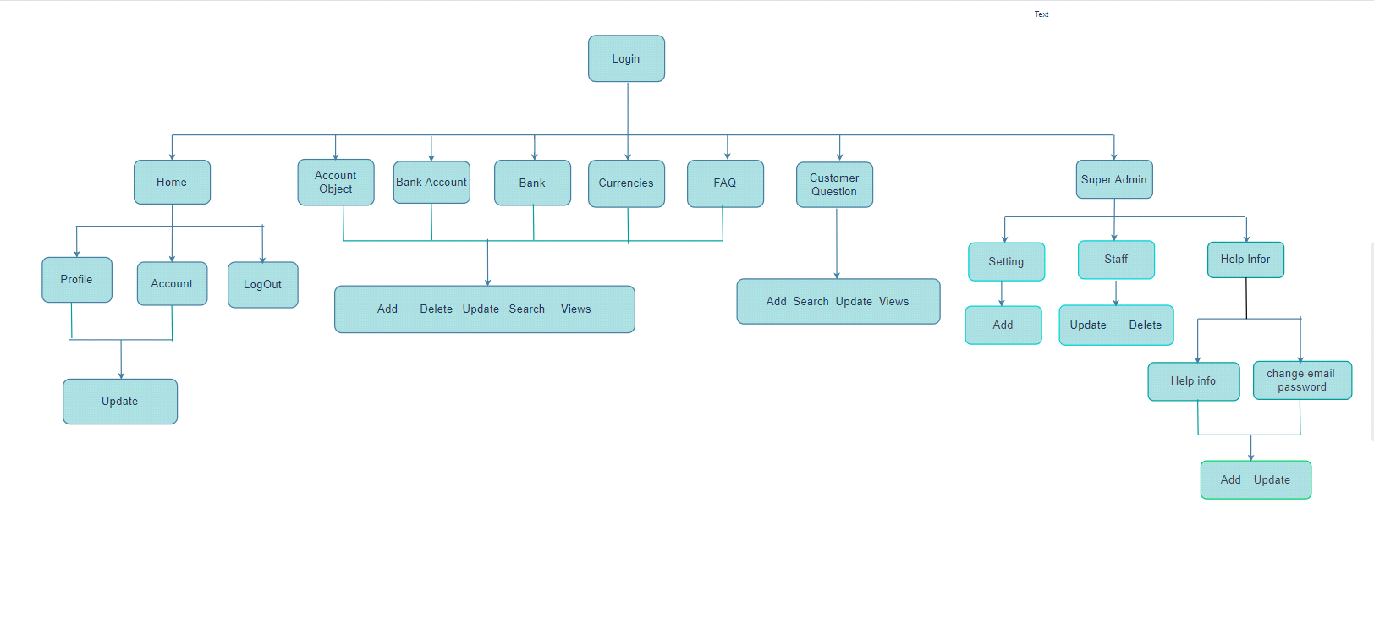

* **Purpose of the application:**

This project will aim at creation of a secure Internet banking system. This will be accessible to all customers who have a valid User Id and Password. This system provides the following facilities:

•- Balance Enquiry

•- Funds Transfer to another account in the same bank

•- Request for cheque book/change of address/stop payment of cheques.

•- Viewing Monthly and annual statements.

**Chapter II: Tender requirement**

* **Functional requirement:**

Following is a list of functionalities of the system. More functionalities that you find appropriate can be added to this list.

- Customer must have a valid User Id and password to login to the system

- If the wrong password is entered three times in a row, the account will be locked and cannot be used by the customer. When an invalid password is entered, the user will be warned that their account will be locked.

- After the valid user logs in he is shown the list of accounts he has with the bank.

- Upon selecting the desired account, he is taken to a page showing the current balance in that particular account number

- User can request details of the last ‘n’ number of transactions he has performed. A report can also be taken of this.

- User can make a funds transfer to another account in the same bank. User is provided with a transaction password which is different from the login password.

- User can transfer funds from his account to any other account with this bank. If the transaction is successful a notification should appear to the customer, in case it is unsuccessful, a proper message should be given to the customer as to why it failed.

-User can request for cheque book/change of address/stop payment of cheques

- User can view his monthly as well as annual statements. He can also take print out of the same.

- Proper help to be provided as and when requested by the user. Chapter III: E-Project design

* **Non-Functional Requirement**

A minimum computer system that will help you access all the tools in the courses is a Pentium 166 or better.

A screen with resolution 1600:900 or better.

128 Megabytes Gigabytes of RAM or better.

**Chapter III: E-Project design**

* **DFD Design for eProject:**
* Define DFD
* Data Flows Diagram (DFD) describes the information flow in the system. The next step of system analysis is to consider in detail the information necessary for the implementation for functions discussed above and the one necessary for the improvement of the functions. Modeling tool frequently used for this purpose is DFD. DFD will support 4 main activities.
* **Analysis:** DFD is used to determine requirement of users. From DFD, all system stakeholders can share the same view on how the data will flow within the system and between the functions.
* **Designing:** DFD is used to map out plan and illustrate solution to system analysts and other stakeholders while designing a new system.
* **Communication:** DFD provides simplicity and ease-to-understand to system analysts as well as other stakeholders.
* **Document**: DFD is used to provide special description of requirement and system design. DFD provide an overview of key functional components of the system, along with other tools like database dictionary, process specification, relevant stakeholders will get the idea of which information will be exchanged and how.
* **Main components of DFD**
* 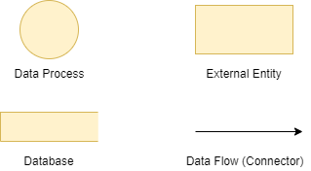**DFD Analysis: Design main functions of system**

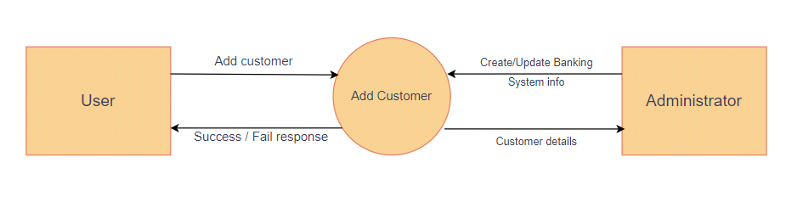

Level 0. Make Online Banking

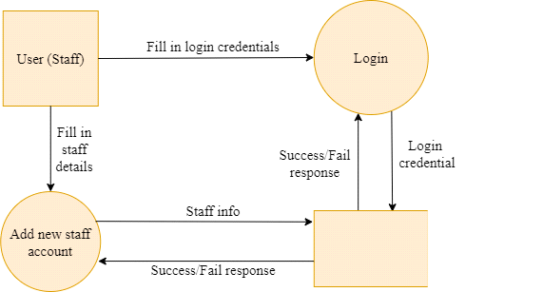

Level 1. Login and add new staff.

* **Database structure design for eProject**

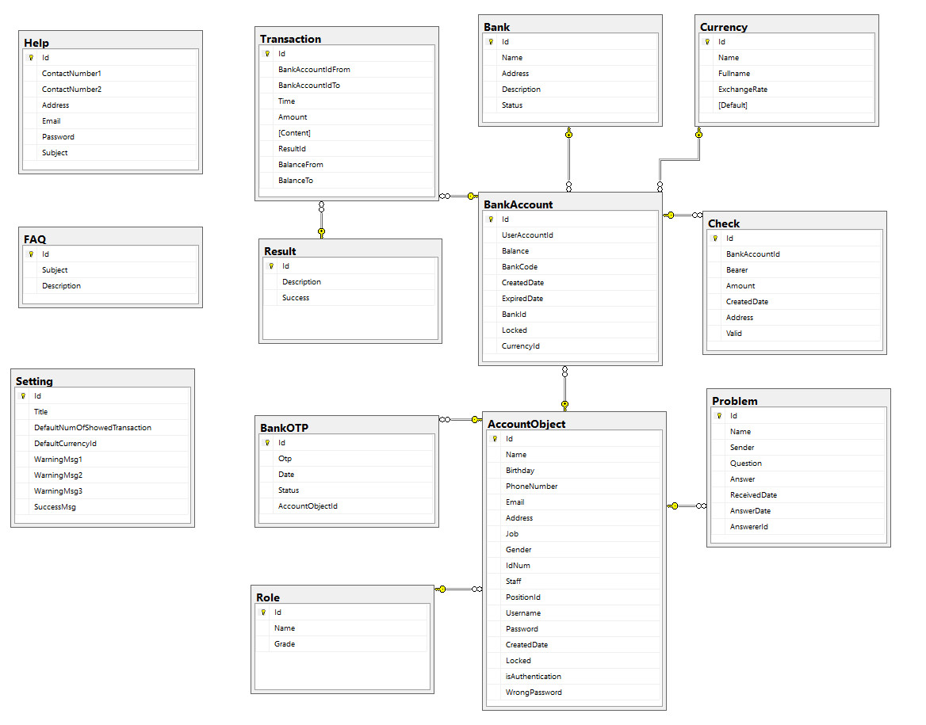

**Chapter IV: Interface snapshot**

1 - Parges for User:

* **Home:**

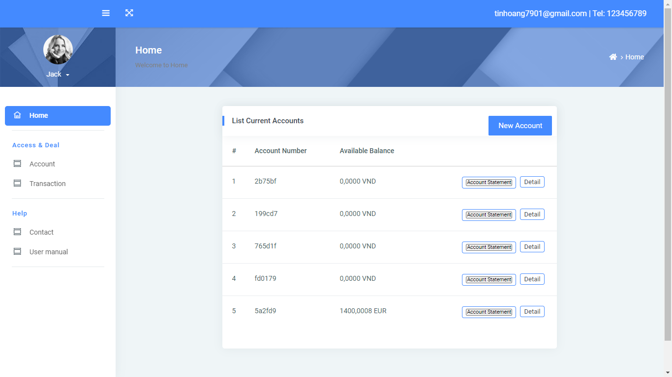

* **Account:**
* 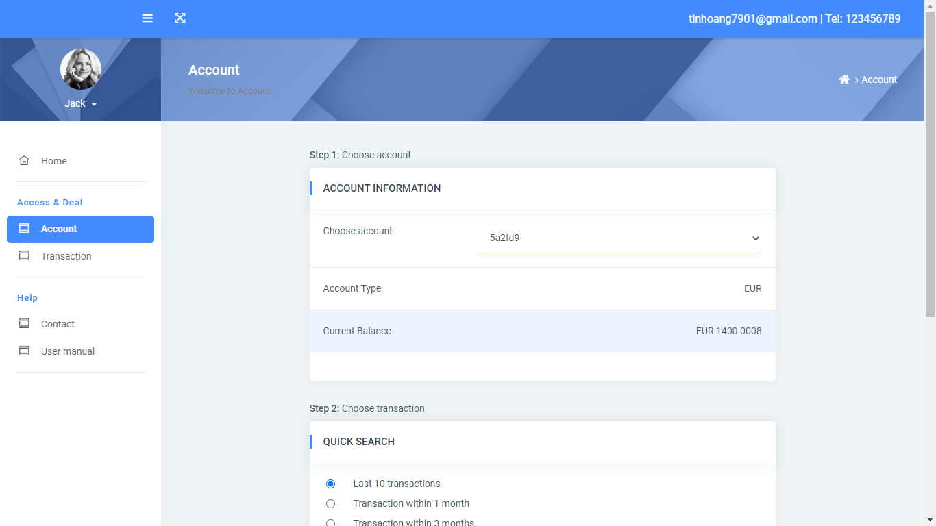

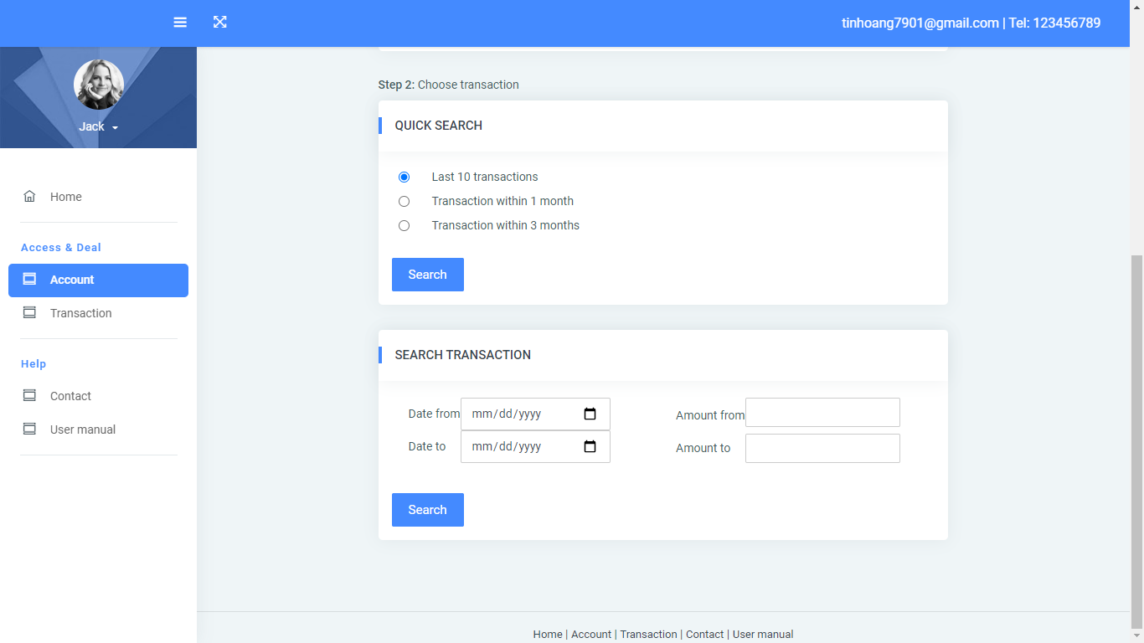

* **Transaction:**

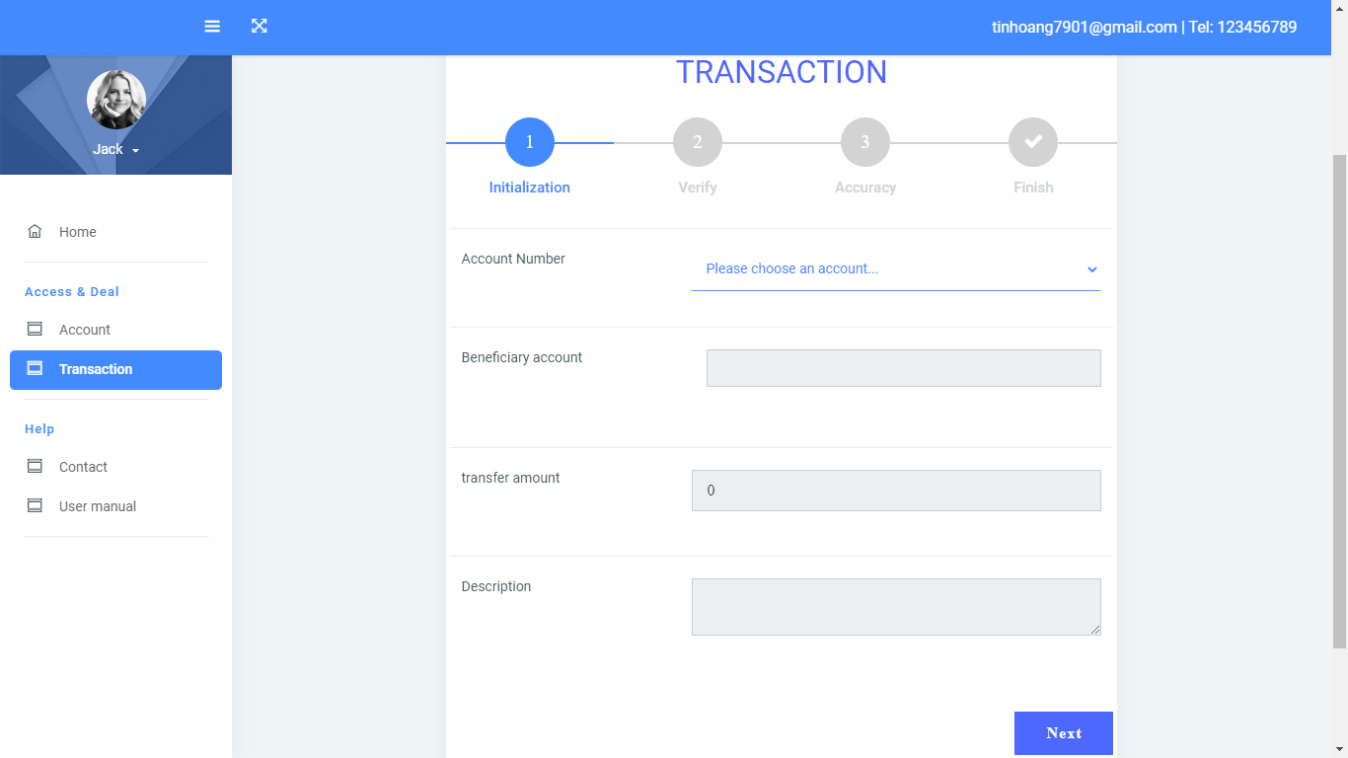

* **Contact us:**

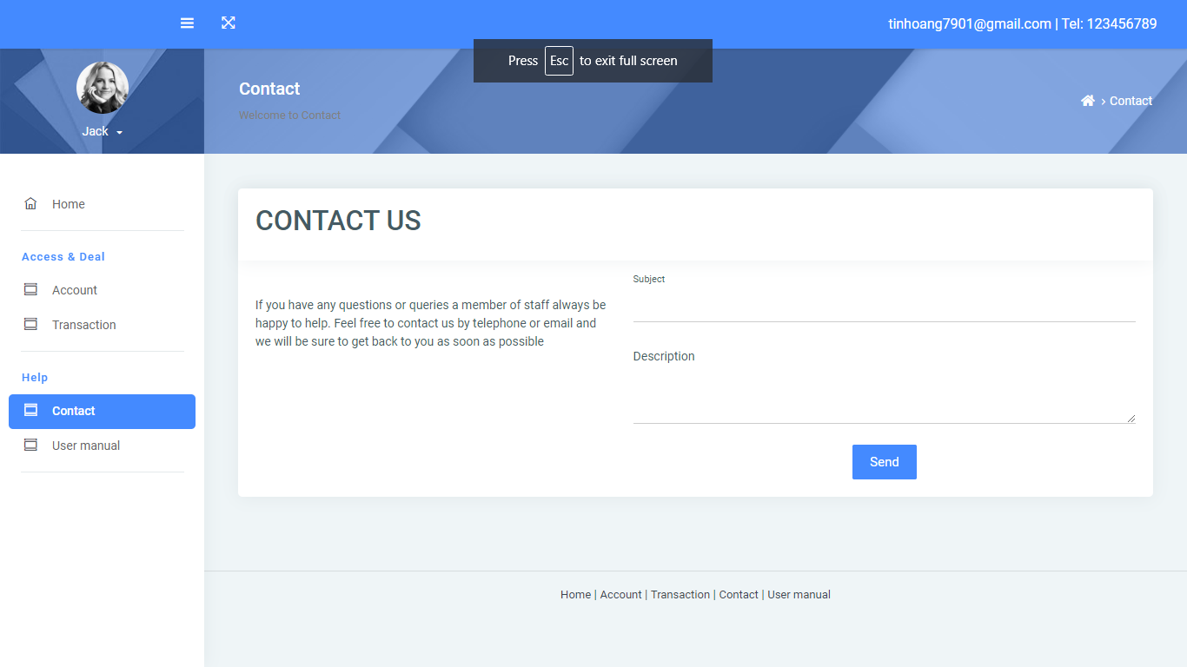

* **User Manual:**

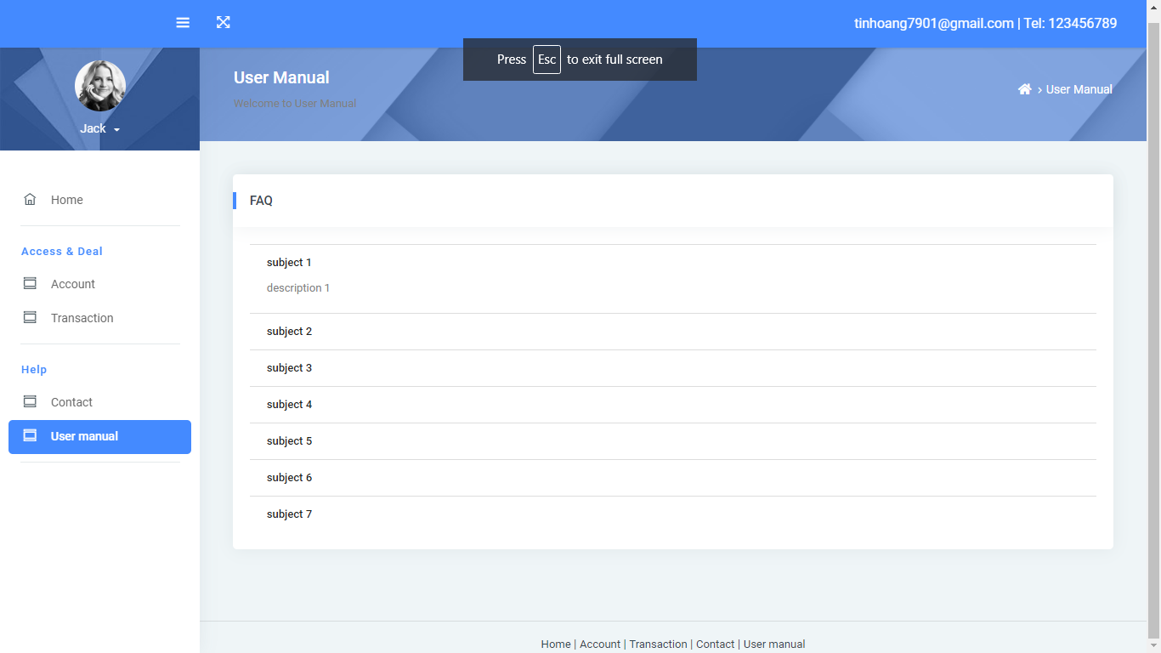

* **Profile:**

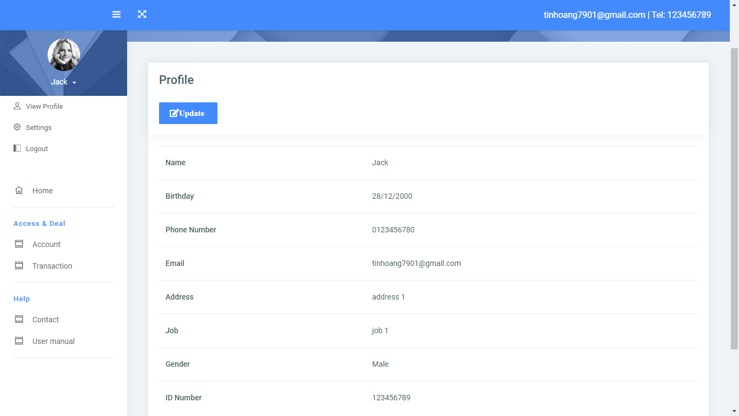

* **Setting:**

**A - change password:**

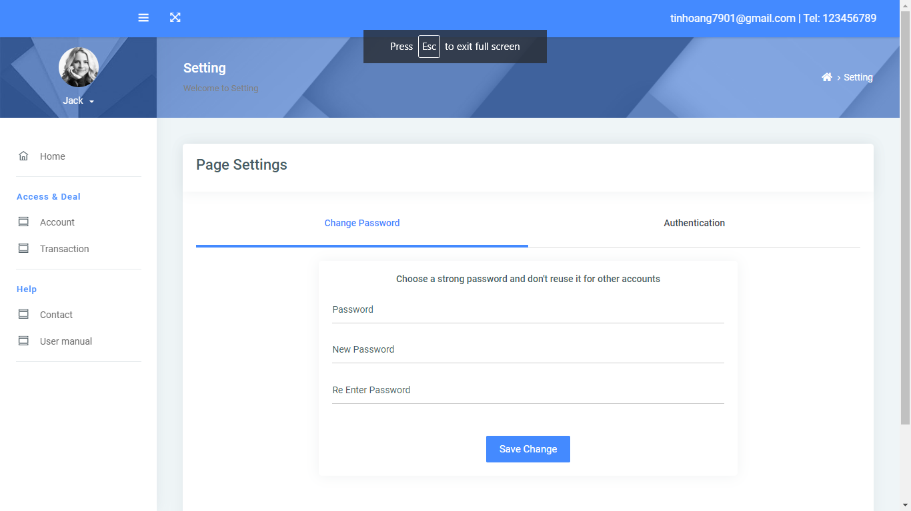

**B - Authentication:**

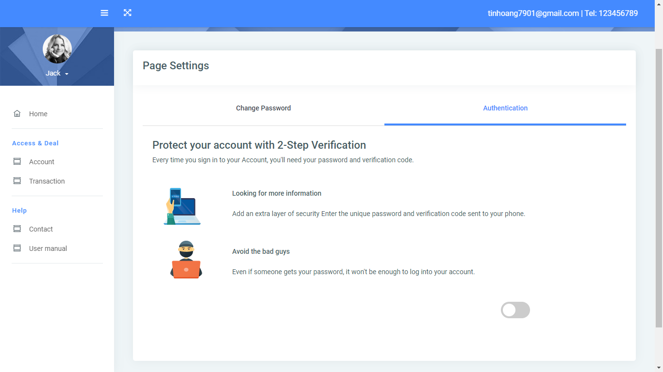

2 - Parges for Admin:

* **Home page:**

**A - Profile:**

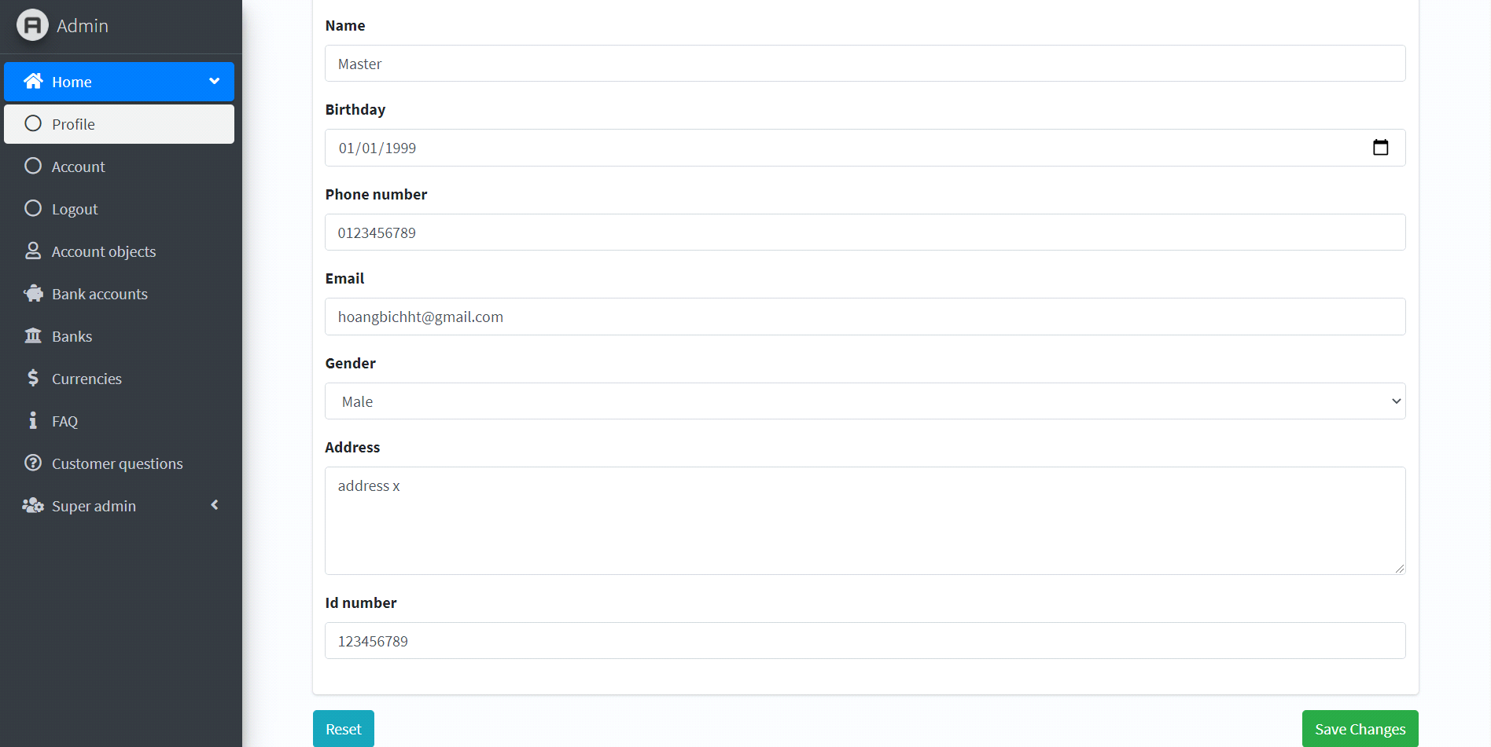

**B - Account:**

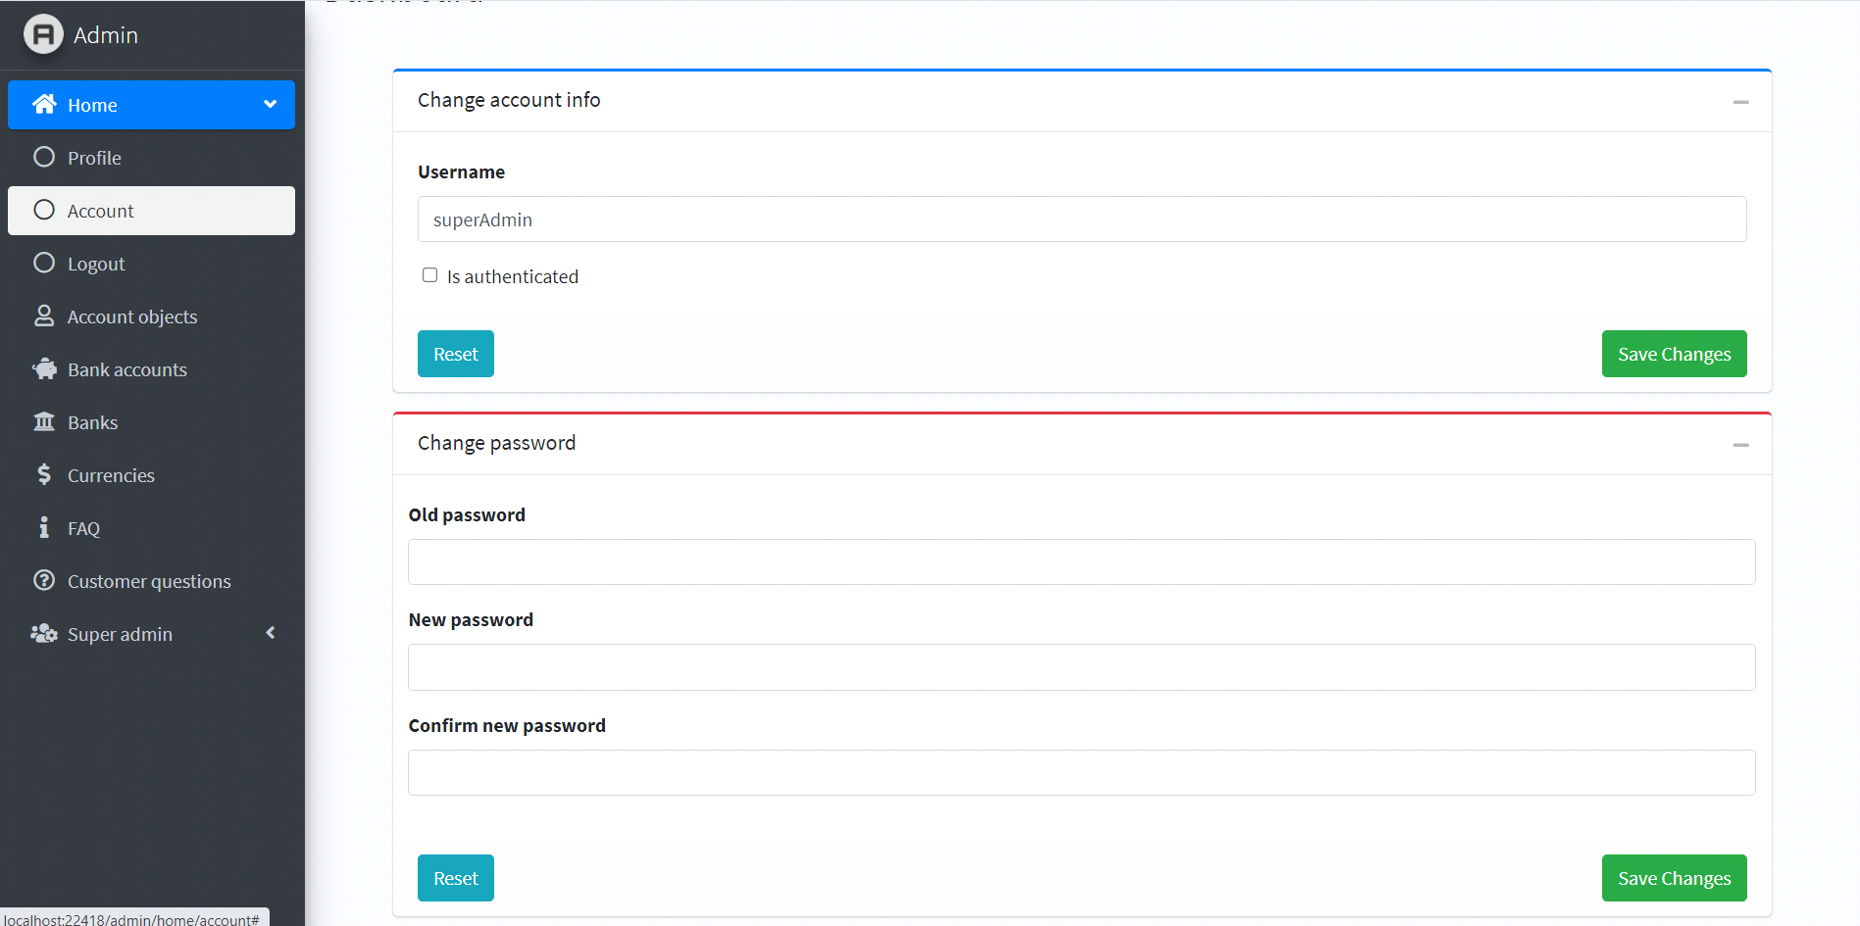

* **Account object page:**

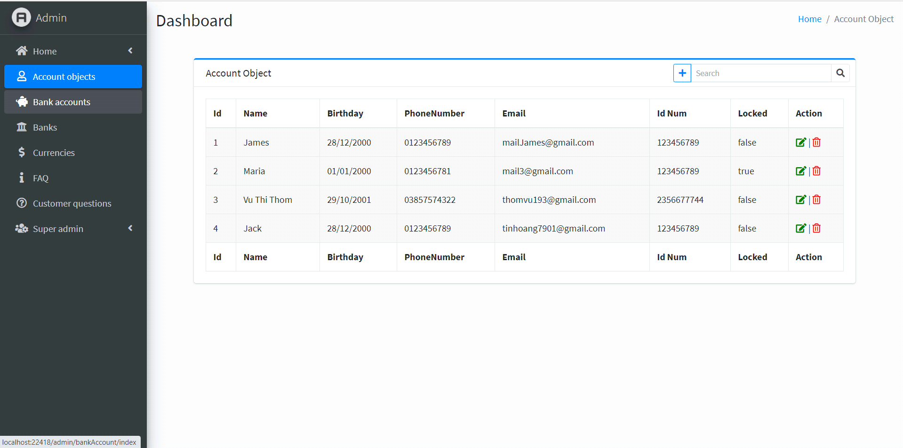

* **Bank accounts page:**

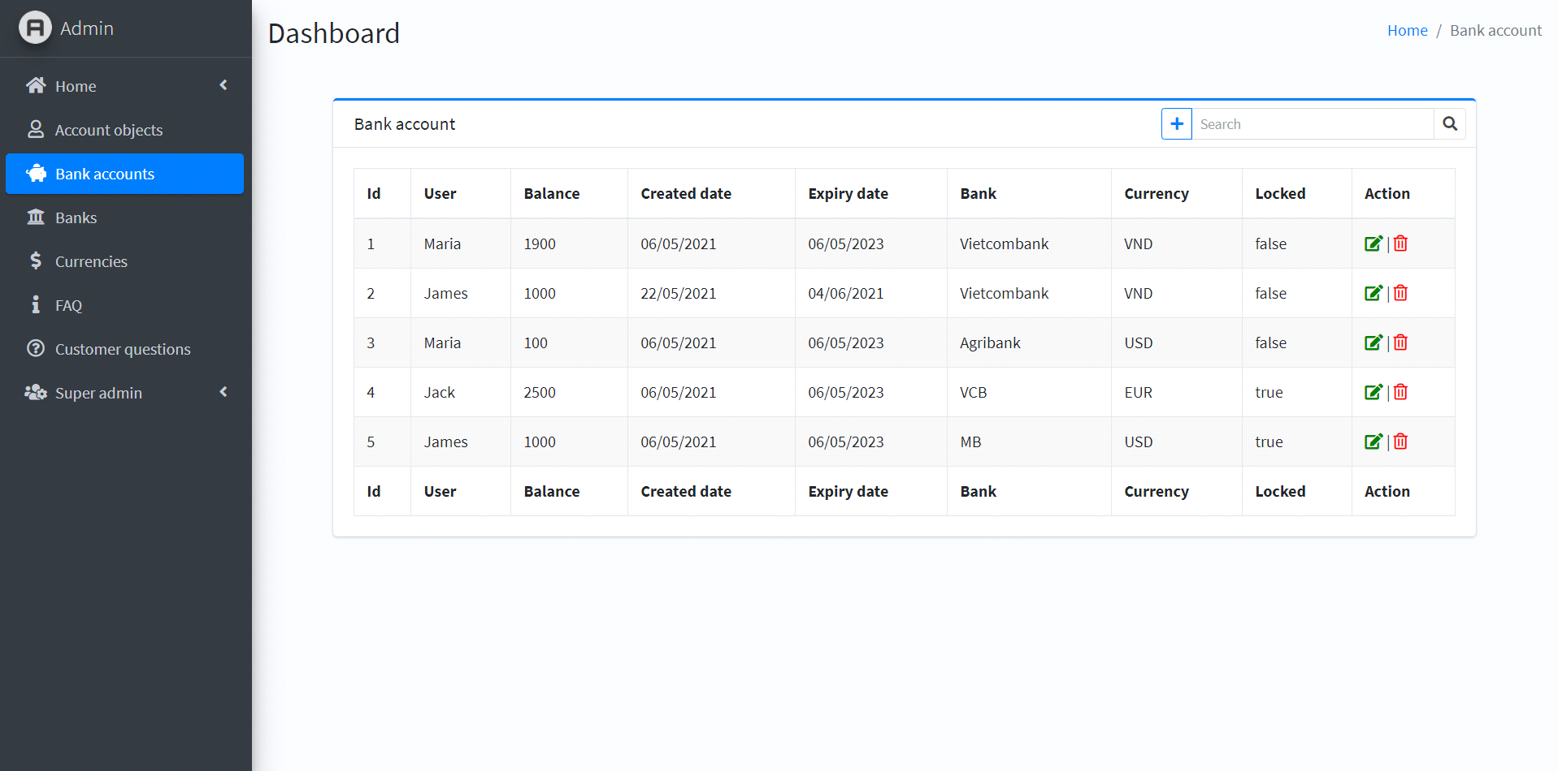

* **Bank page:**

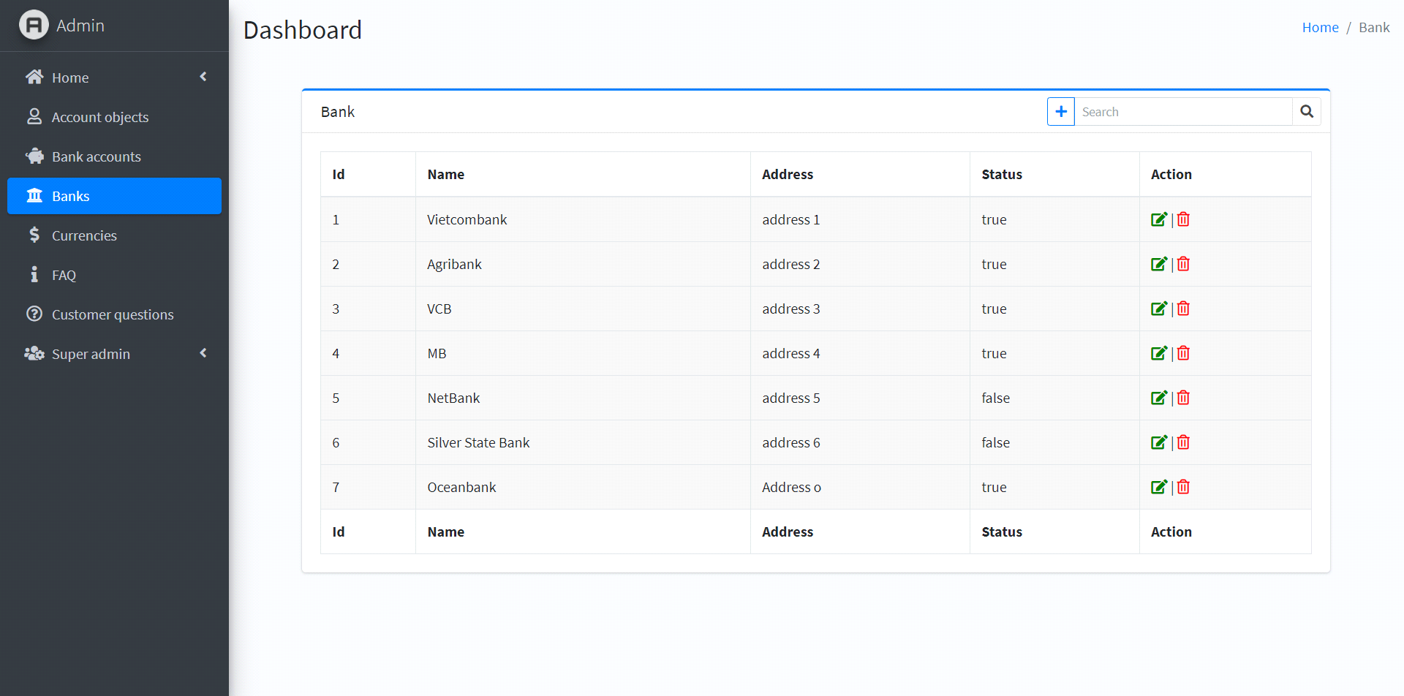

* **Curencies page:**

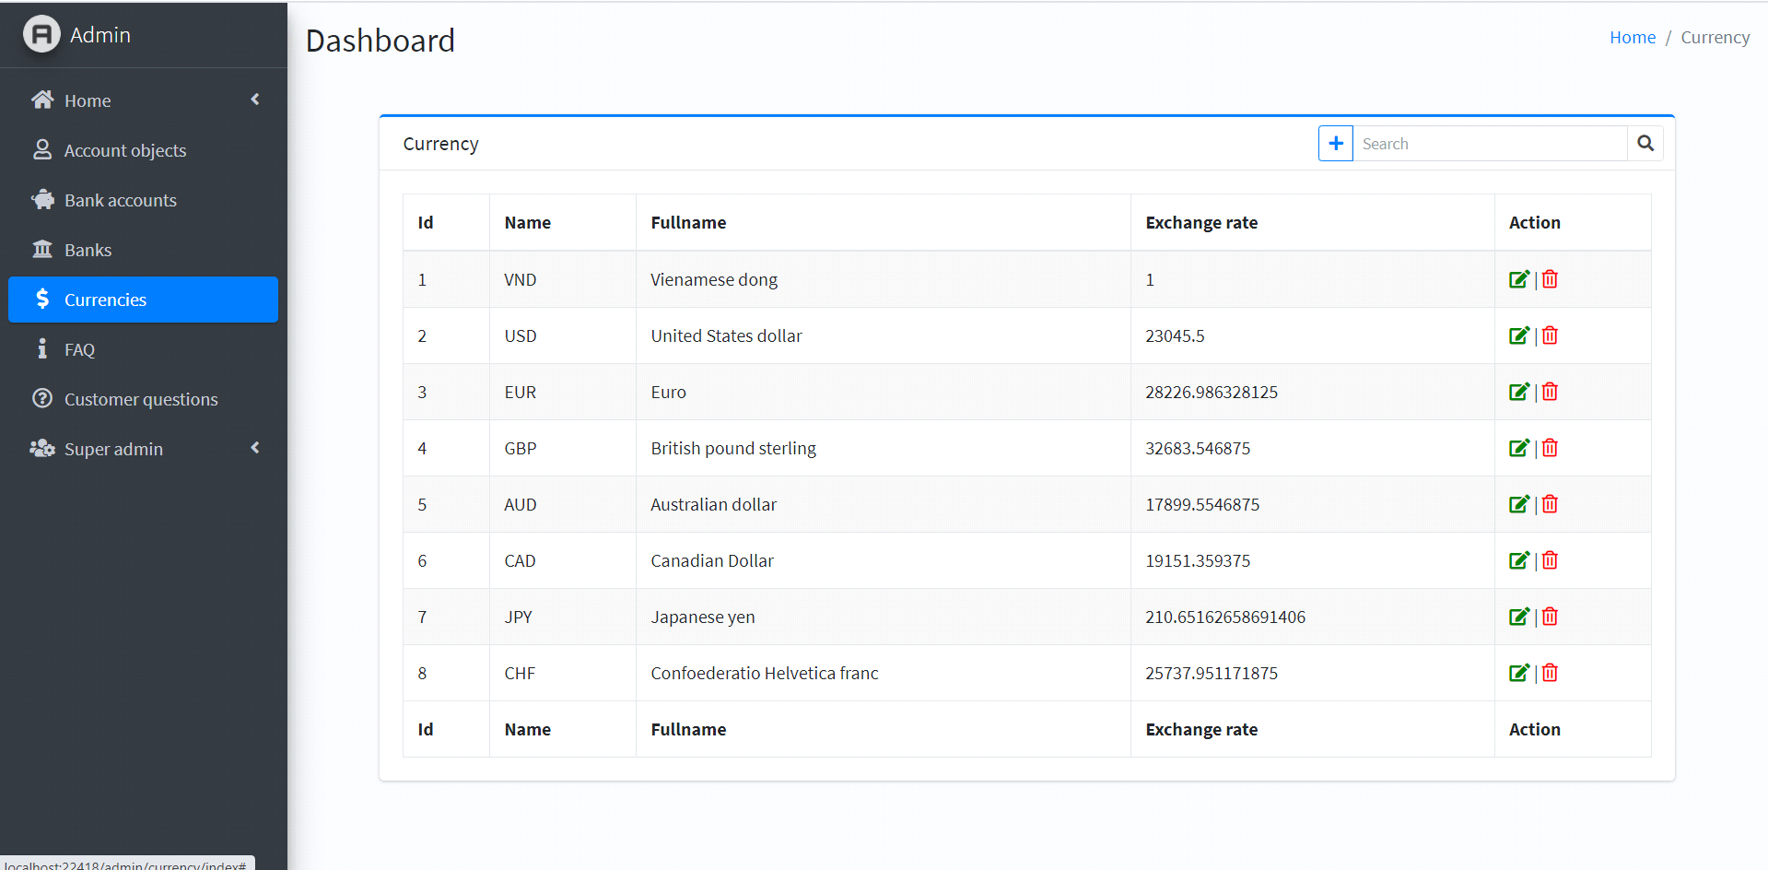

* **FAQ page:**

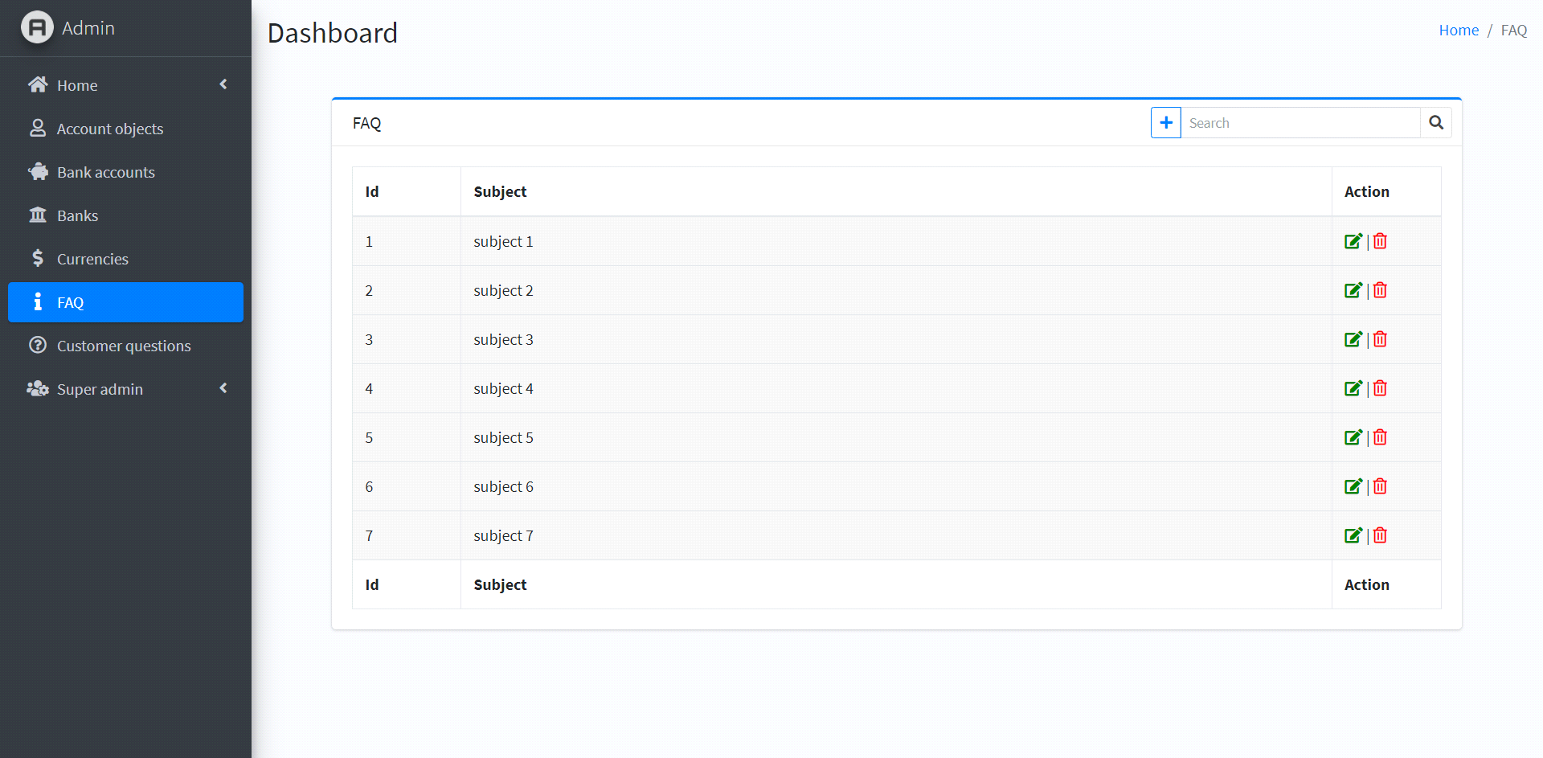

* **Cutomer questons page:**

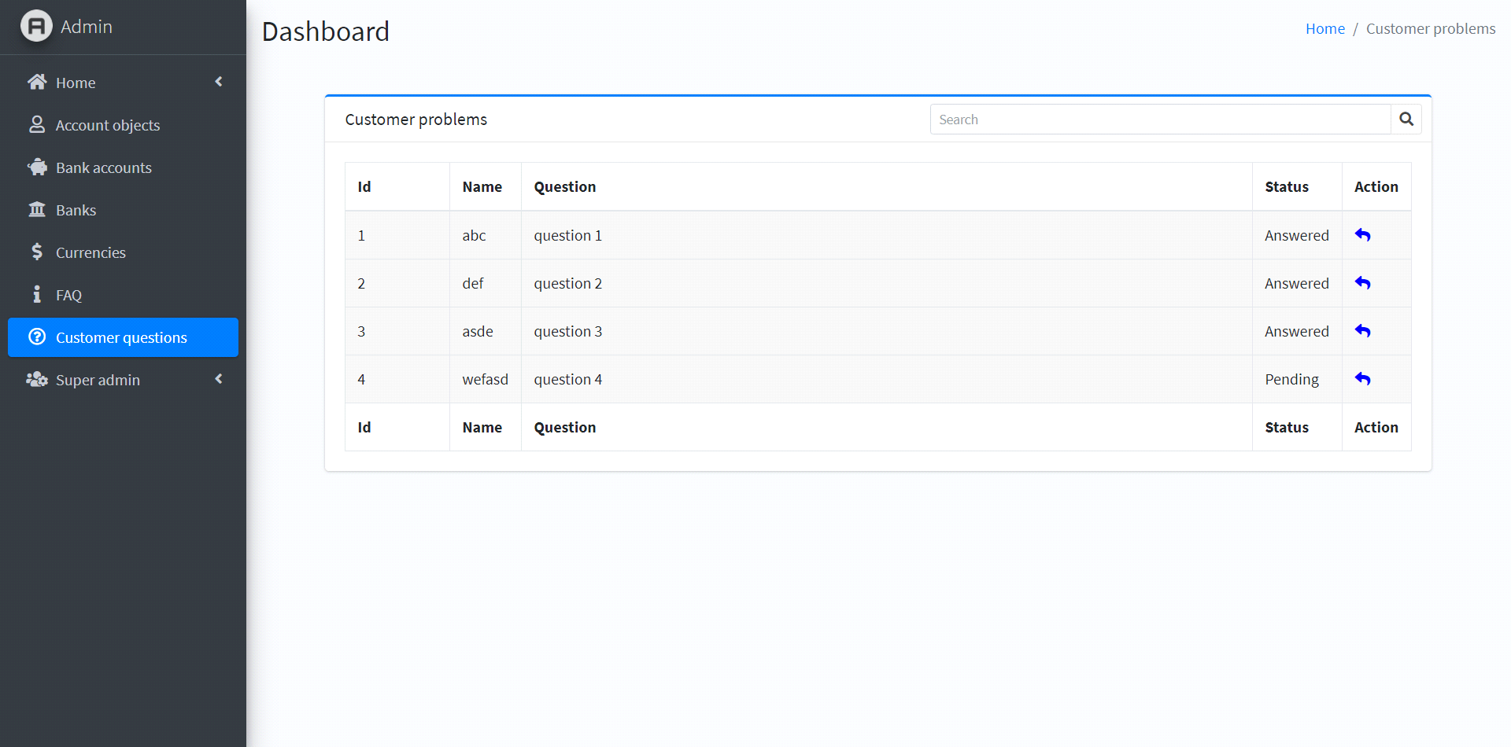

* **Super admin page:**

**A - Setting**

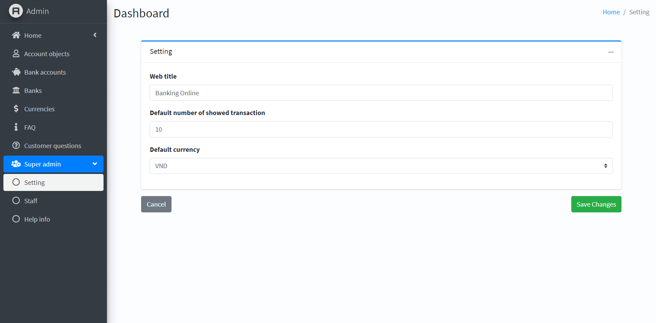

**B - Staff**

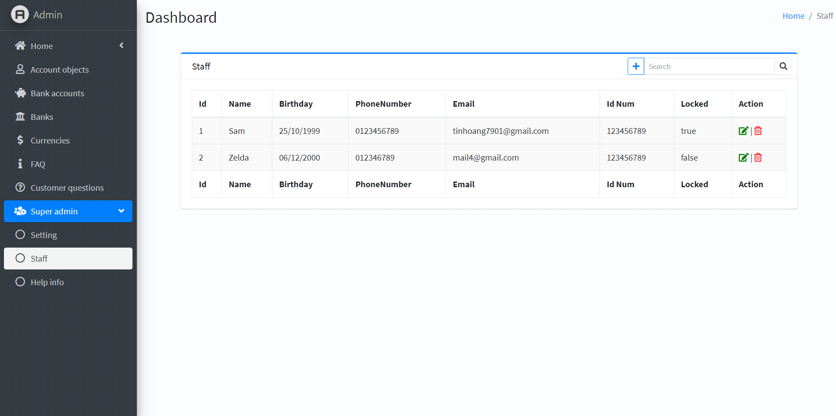

**C - Help info**

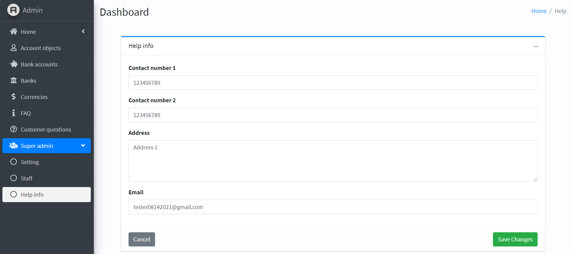

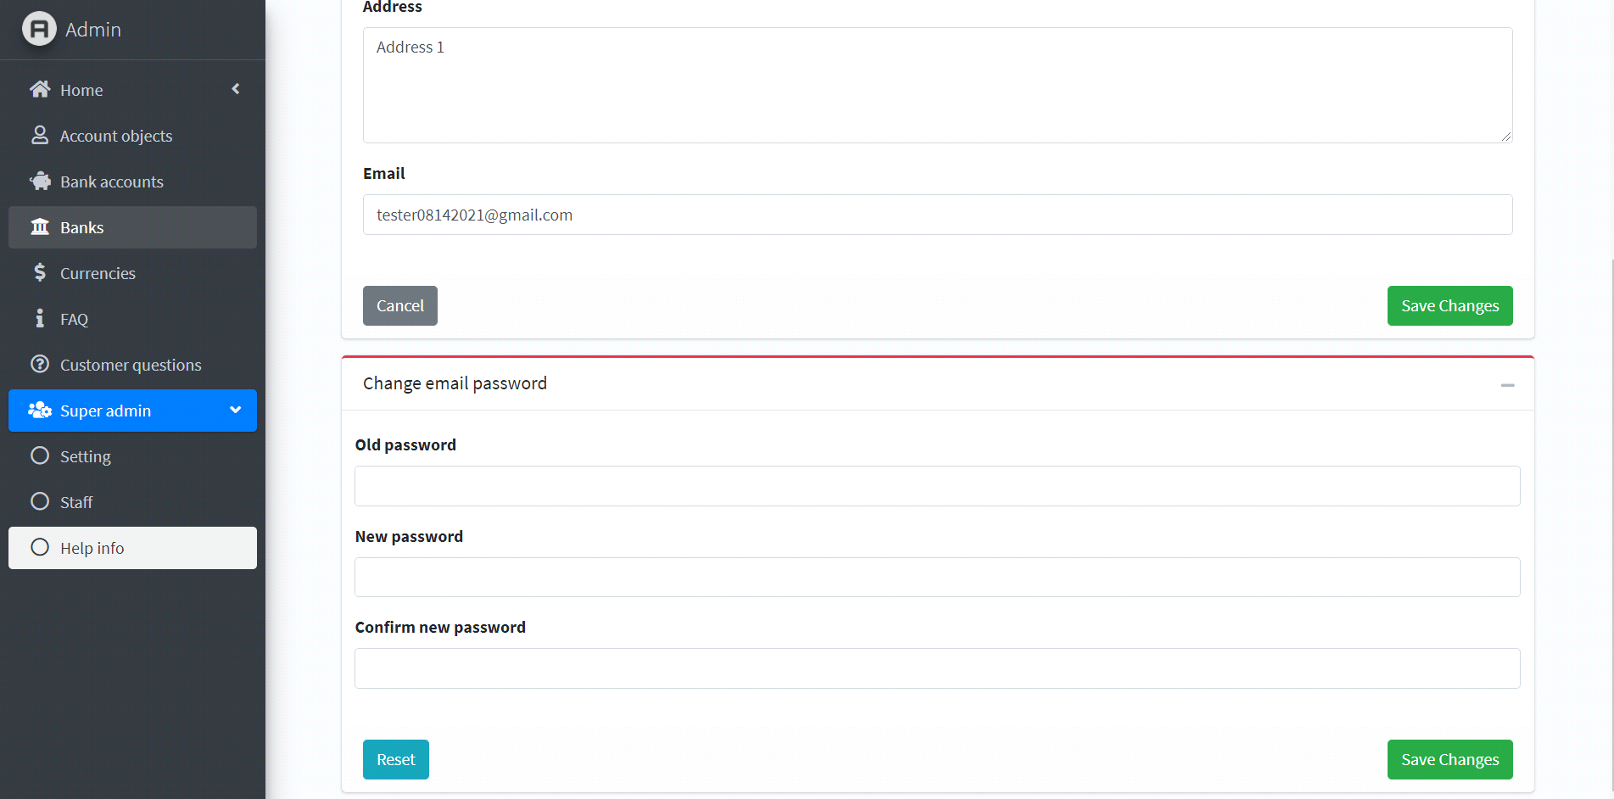

**Chapter V: User guide**

* **Login page:**
* **Description:**
* The login page of the application will be the default page that end user will see after they starts the application. The login page includes the following information/sections:
* Username and password field.
* Remember username checkbox.
* **Design and Operation:**
* Login page:
* To login, user must fill in all mandatory fields:

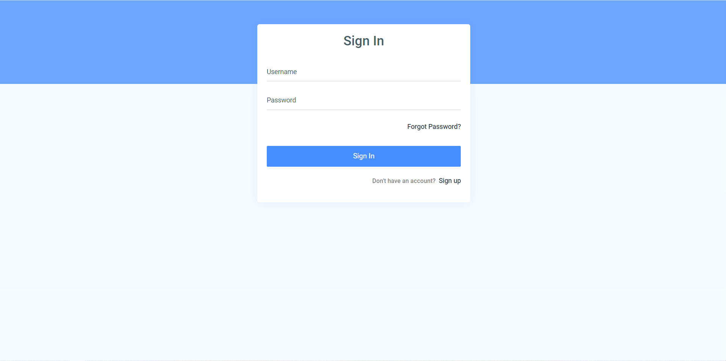

|  |  |
| --- | --- |
| **Fields** | **Description** |
| Username | * This field is mandatory. * User fill in his/her username here. |
| Password | * This field is mandatory. * User fill in his/her password here. |
| Forgot Password | * Users can access the forgot password page when they forget their old password. |
| Sign up | * Register a new account. |

* **Resgister page:**
* **Description:**
* The forgot password of the website page is the page that resets the password for users when they forget their old password. The forgot pasword page includes the following information/sections:
* Phone number field, identity number field and email address field.
* **Design and Operation:**
* Forgot password page:
* To receive a new password by email, user must fill in all mandatory fields:

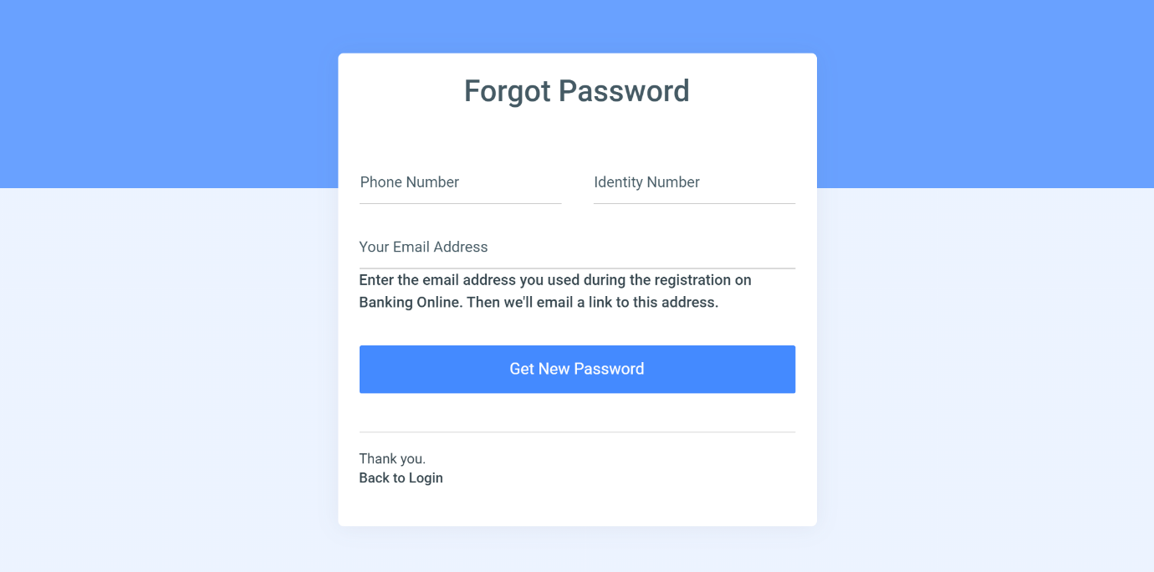

|  |  |
| --- | --- |
| **Fields** | **Description** |
| Phone number | * This field is mandatory.   • The user enters the phone number registered for the account here. |
| Identity Number | * This field is mandatory. * The user enters the phone number registered for the account here. |
| Email Address | * This field is mandatory. * The user enters the email address registered for the account here. |

* **Sign up page:**
* **Description:**
* The sign up of the website page is the page that allows users to register for a new account. The sign-up page includes the following information/sections:
* Name field, birthday field and email address field.
* Email address field, phone number field, job field and gender field.
* Address field, Username field, password field and confirm password field.
* **Design and Operation:**
* Sign-up password page:
* To register for a new account, user must fill in all mandatory fields:

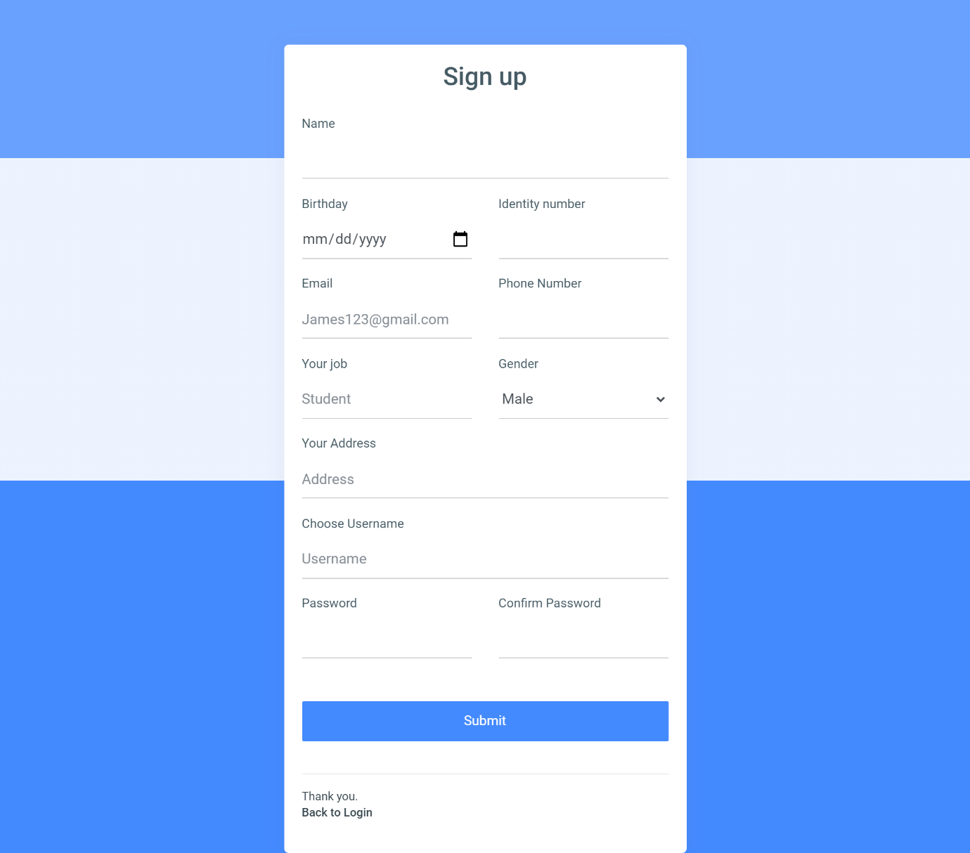

|  |  |
| --- | --- |
| **Fields** | **Description** |
| Name | * This field is mandatory. |
| Birthday | * This field is mandatory. * The user must be 18 years old. |
| Identity number | * This field is mandatory. * The User enters his/her identity number here. Identity number must be unique. |
| Email | * This field is mandatory. * The User enters his/her email here. Email must be unique. |
| Phone number | * This field is mandatory. * The User enters his/her phone number here. Phone number must be unique. |
| Job | * This field is mandatory. |
| Gender | * This field is mandatory. * The User enters his/her gender here |
| Address | * This field is mandatory. * The User enters his/her address here |
| Username | * This field is mandatory. * The User enters his/her username for account here. Username must be unique. |
| Password | * This field is mandatory. * The User enters account’s password here. Password must have at least 8 characters, 1 number, 1 lowercase, 1 uppercase, and 1 special character from @#$%&. |
| Confirm password | * This field is mandatory. * User enters the confirmation password must match the password. |

* **Authentication page:**
* **Description:**
* when the user chooses to login by two-step authentication then after entering the correct password user will be directed to this page. The authentication page includes the following information/sections:
* passcode field.
* **Design and Operation:**
* Authentication page:
* To login, user must fill in mandatory field:

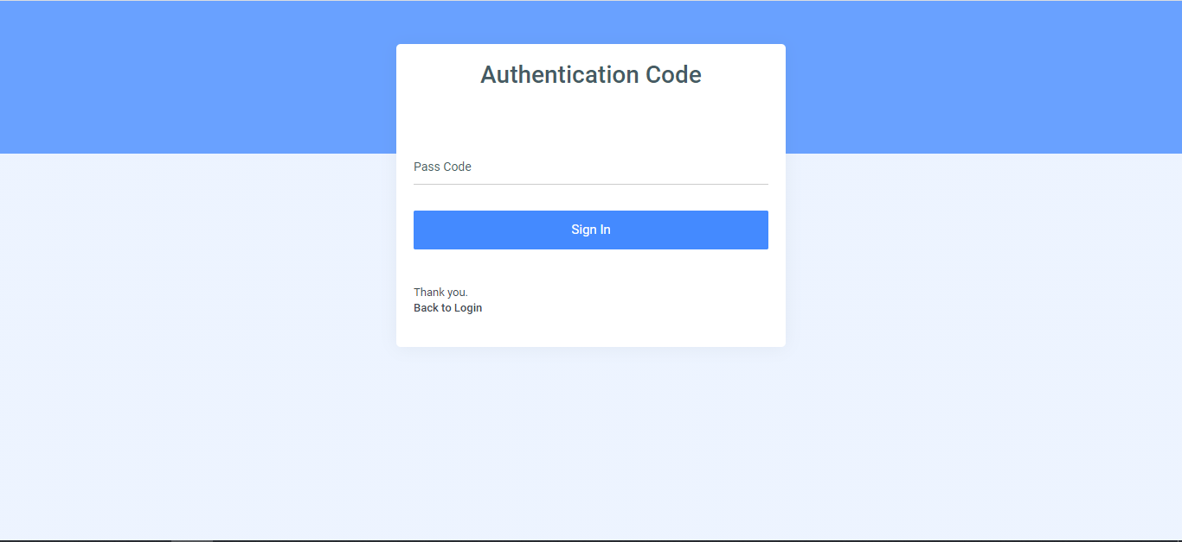

|  |  |
| --- | --- |
| **Fields** | **Description** |
| Passcode | * This field is mandatory.   • The user enters the code provided by the google authenticator app within the valid time |

* **Home page:**
* **Description:**
* The homepage of the application will be the default page that end users will see after they login into the application. The homepage includes the following information/sections.
* **Design and Operation:**
* User can check the balance.

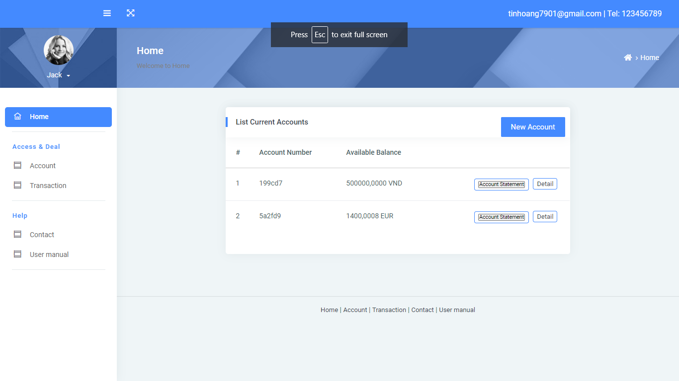

* Users can view account details by clicking the detail button.

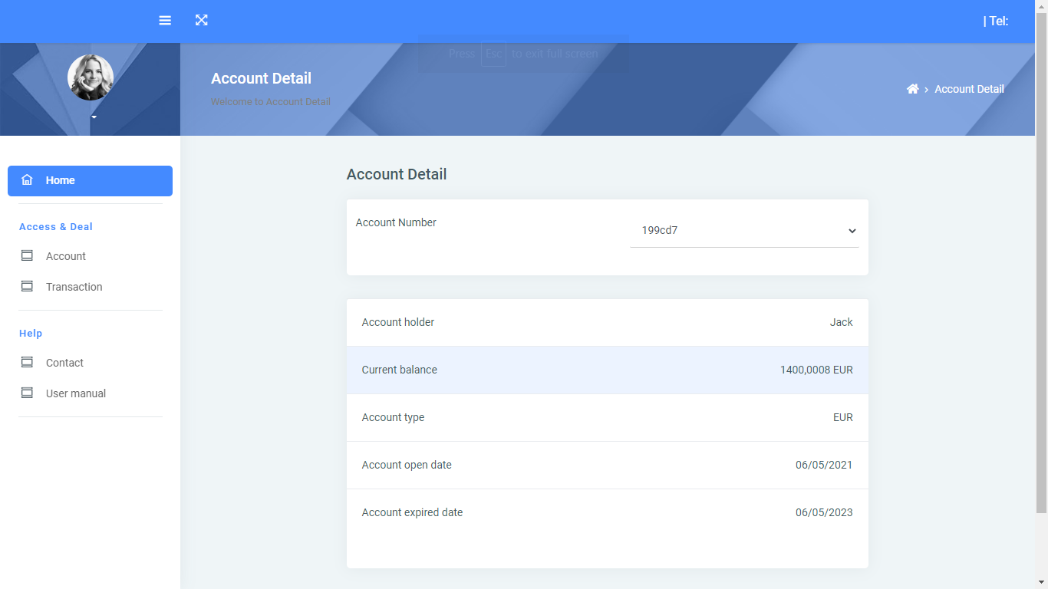

* Users can view account statement by clicking the account statement button. They can generate reports with account statement.

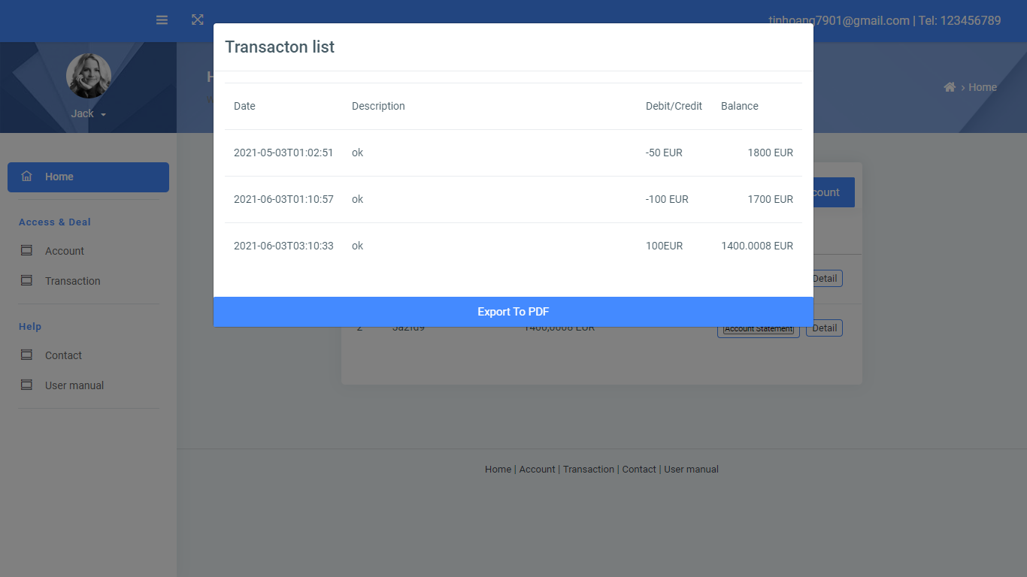

* Menu bar to access other pages and welcome interface.
* Logout: Users can logout and return to login page.

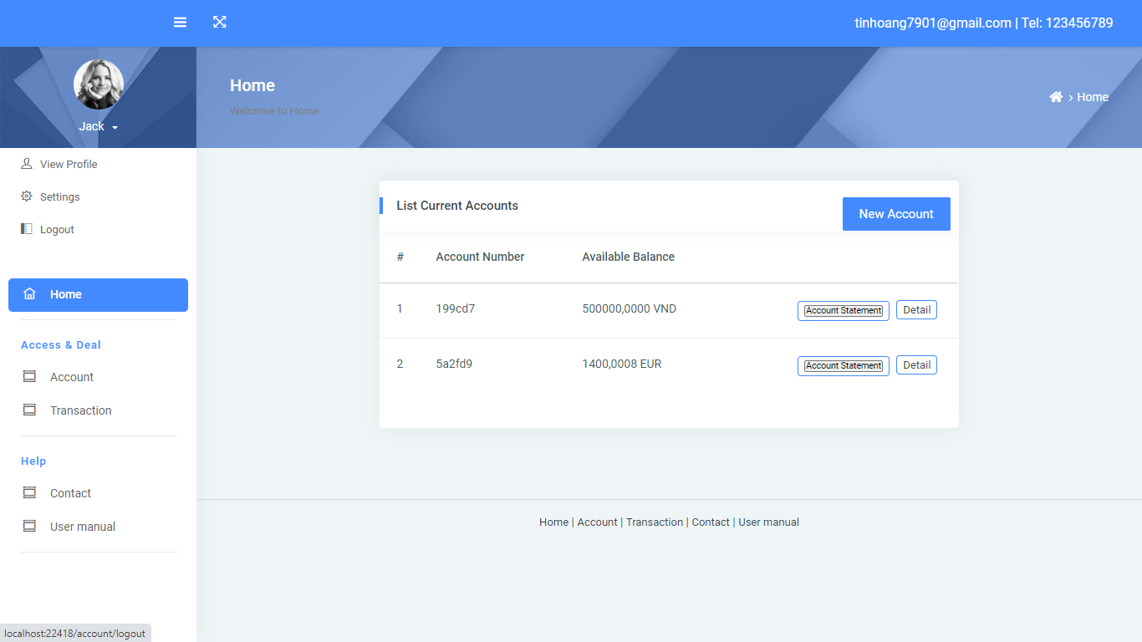

* **View Profile page:**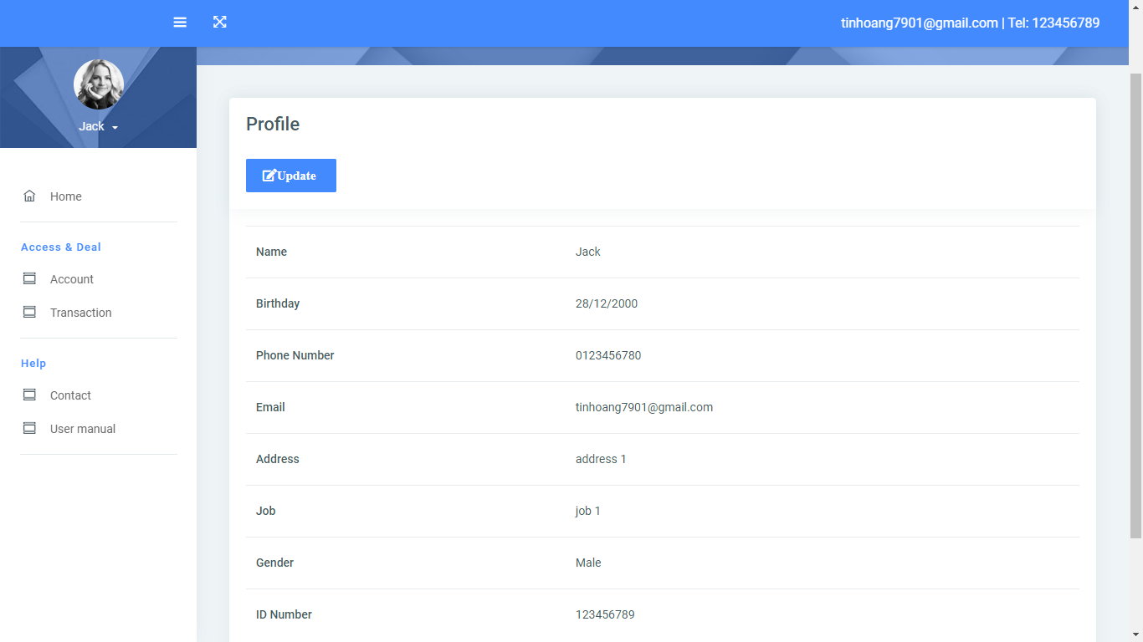

**-** Display user's personal information

- Edit user information

* **Setting page**
* **Change password**

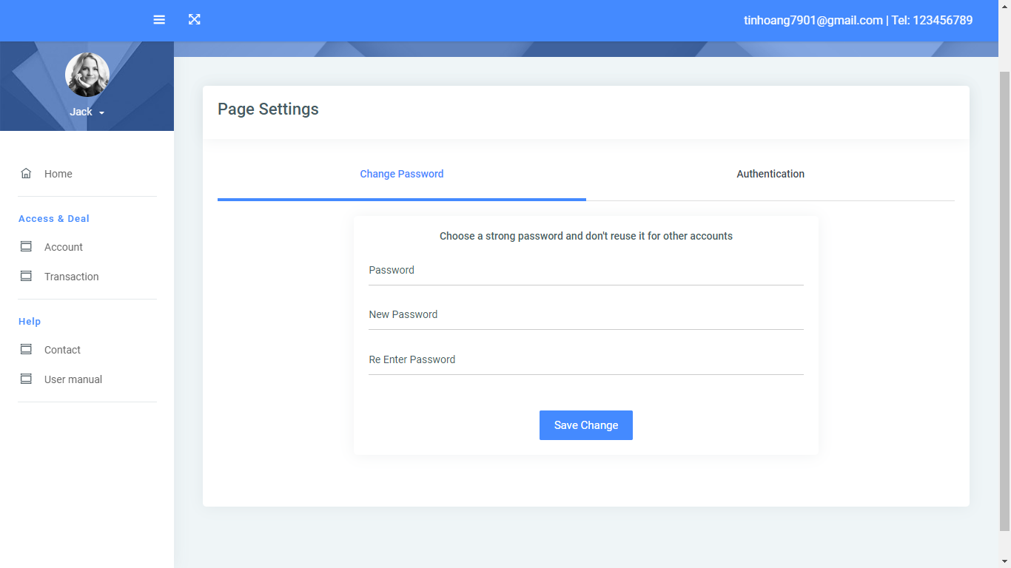

* Users need to enter old password to change new password.
* **Authentication**

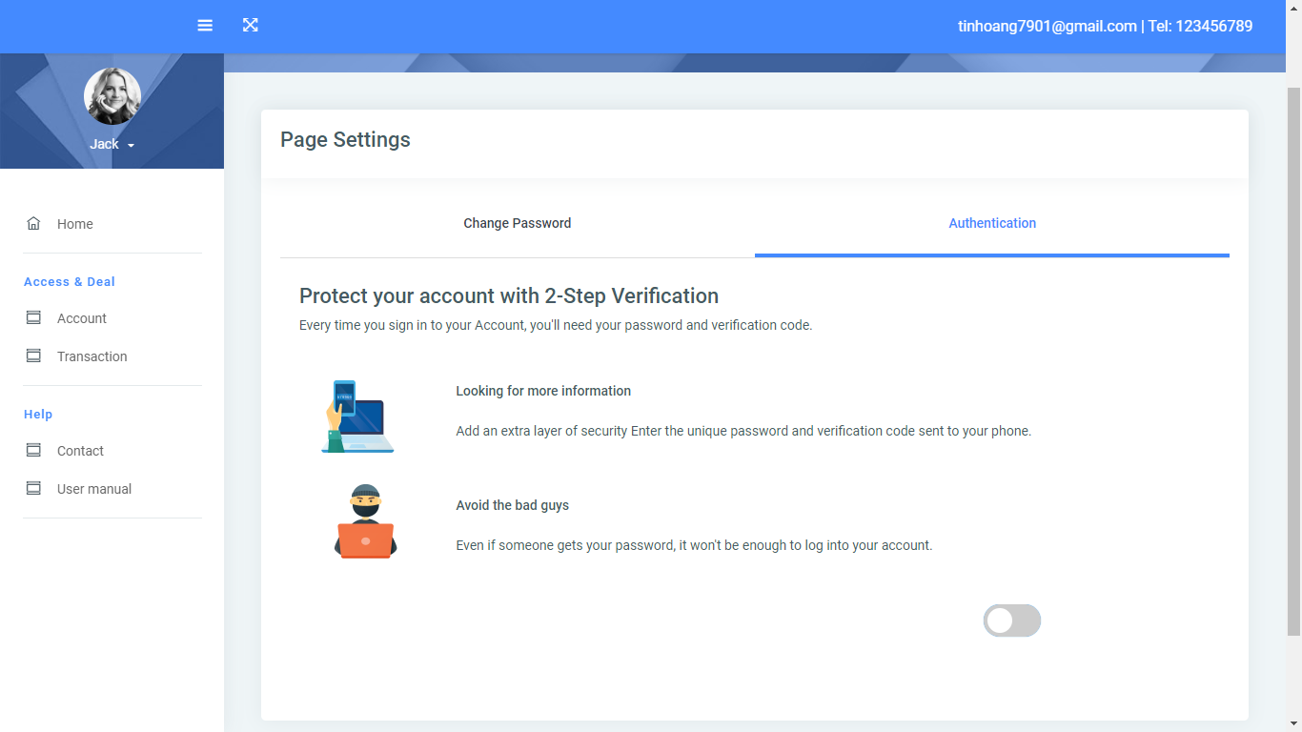

* Protect user's account with 2-step verification.

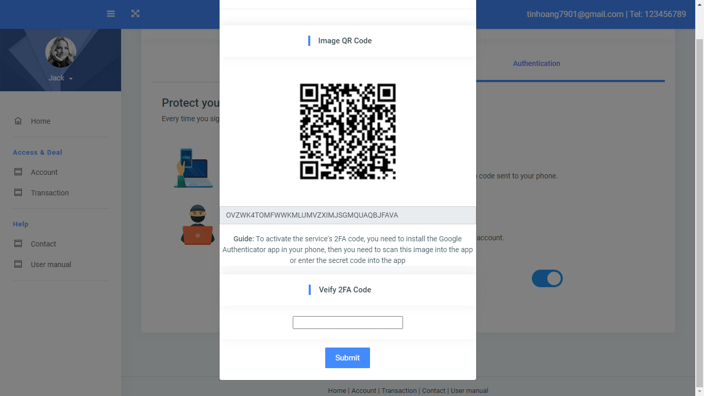

* To activate the service's 2FA code, you need to install the Google Authenticator app in your phone, then you need to scan this image into the app or enter the secret code into the app.

|  |  |
| --- | --- |
| **Fields** | **Description** |
| Old password | * This field is mandatory. * This field will be checked if it is correct as user’s current password or not. |
| New password | * This field is mandatory. * This will be saved as the new password which user can use to login the account instead of the old one. * New Password can contain alphabet, digit characters and special characters, cannot include space. |
| Confirm password | * This field is mandatory. * This field must be matched with the “New Password” field. |
| Verify 2FA code | * The user needs to enter the code in the account just created with google authenticator |

**5. Account page:**

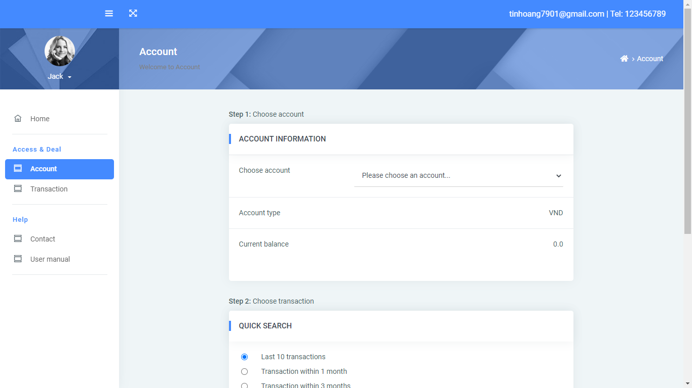



|  |  |
| --- | --- |
| **Operation No.** | **Description** |
| Step 1. | * Details of the amount in the user account |
| Step 2. | * Displays a list of the last 10 transactions. * Show 1 month transaction history list. * Show 3-month transaction history list. * Search transaction history by date and amount |
| Step 3 | * The users can generate reports with transaction histories found. |

**6. Transaction page:**

* Step 1: Initialization transaction.

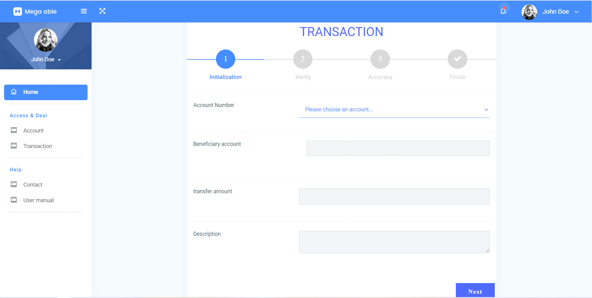

* Step 2: Verify transaction information.

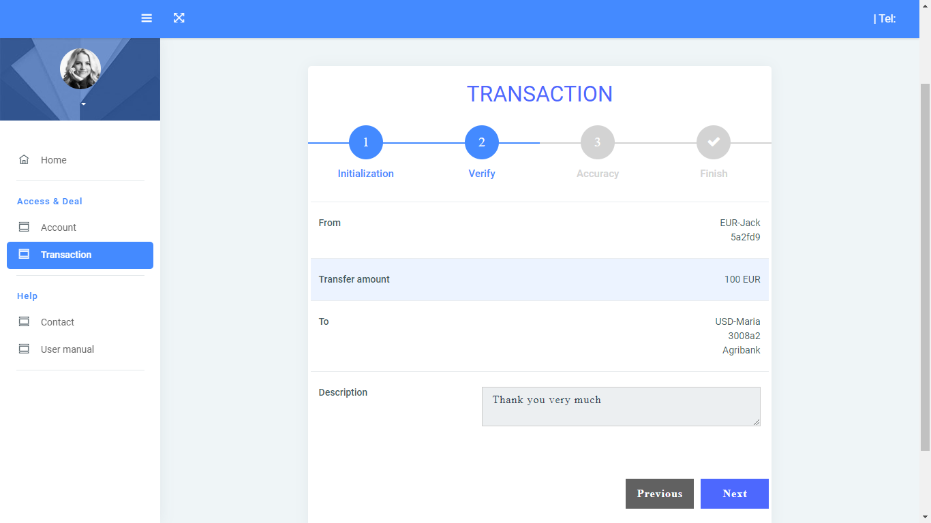

* Step 3: Accuracy with otp code.

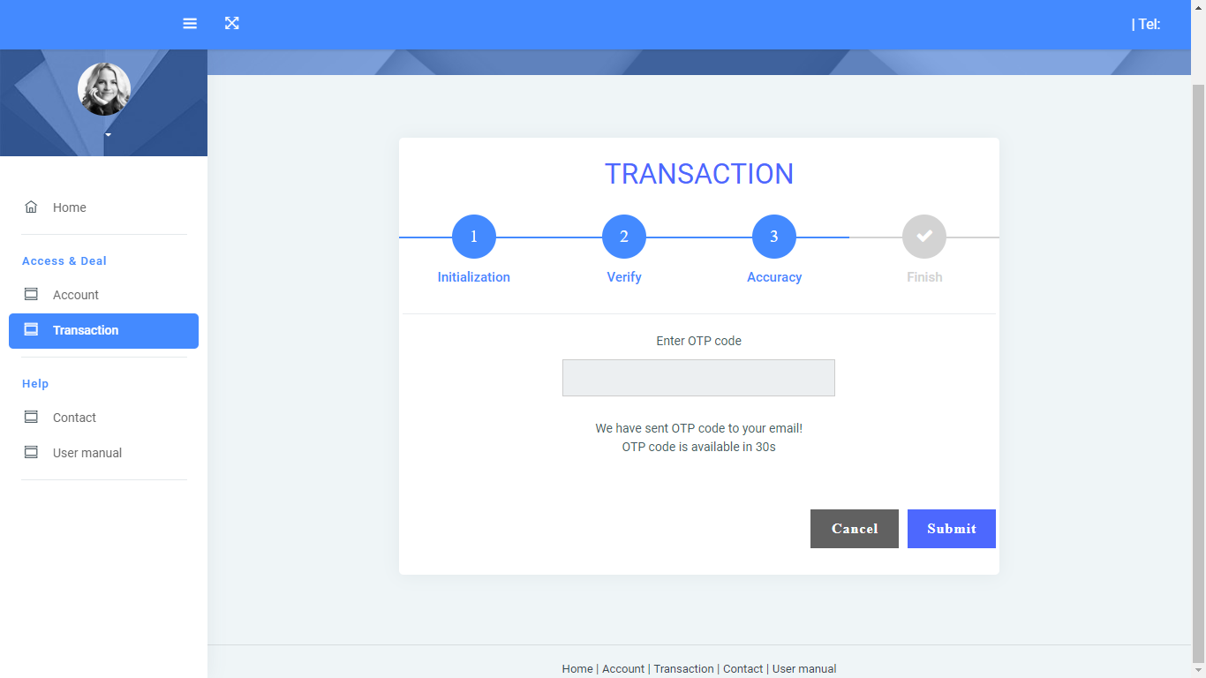

* Step 4: Finish.

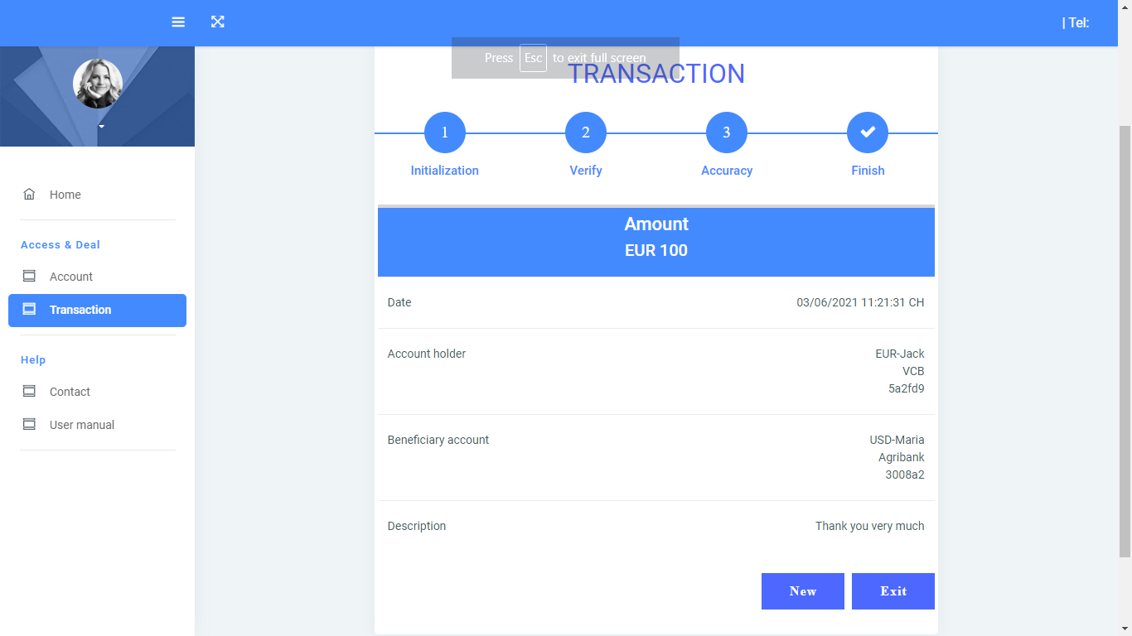

|  |  |
| --- | --- |
| **Operation No.** | **Description** |
| Step 1 | * You can enter Number Account. * Beneficiary account * Transfer Amount * Description |
| Step 2 | * The user needs to check if the transaction information is correct or not? * If correct you need to press next button to go to next step otherwise you can press previous button to go back to step 1. |
| Step 3 | * The system has sent the user an otp code via email to verify this transaction is valid. The otp code is valid for 30 seconds. * The user needs to enter the otp code received by email within valid time. |
| Step 4 | * Successful transaction. The user can create a new transaction or return to the homepage now. |

* View messages: The user needs to enter the recipient's account number amount and the content of the transfer.

**7. Contact us page:**

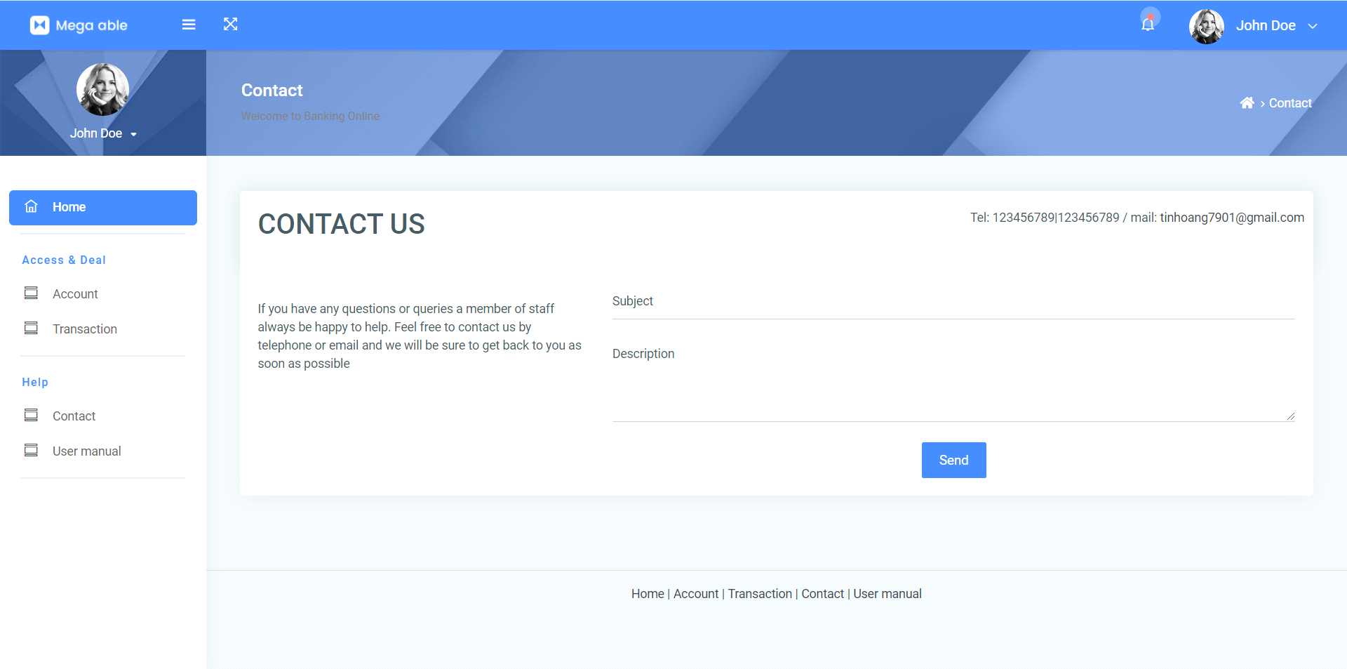

|  |  |
| --- | --- |
| **Operation No.** | **Description** |
| 1 | * users send inquiries directly to the bank |

**8. User Manual page:**

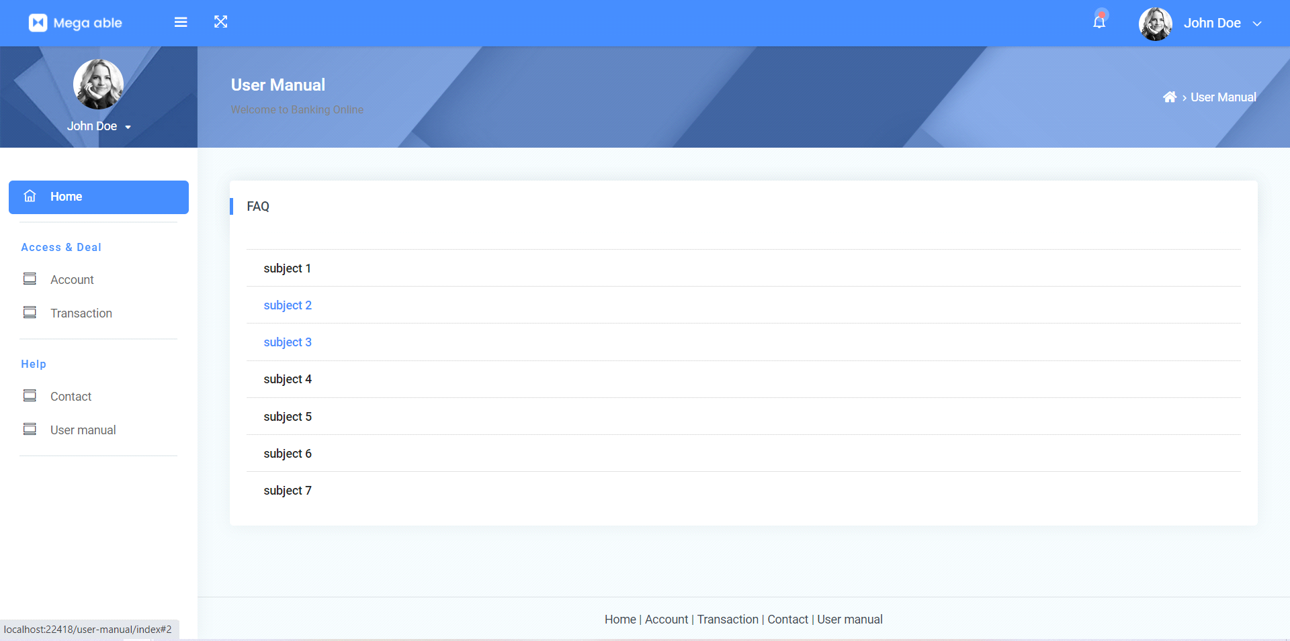

|  |  |
| --- | --- |
| **Opertion No.** | **Description** |
| 1 | * List of Frequently Asked Questions |

**Chapter VI: Admin guide**

1. **Home page**
2. **Profile**

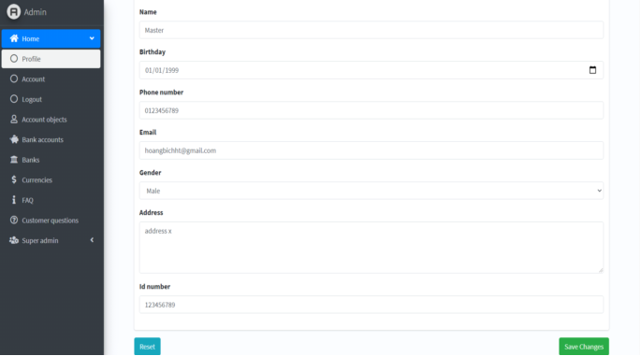

|  |  |
| --- | --- |
| **Operation No.** | **Description** |
| 1 | Display admin information |

**B. Account**

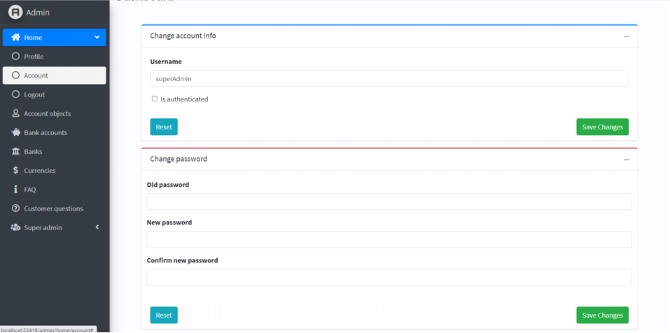

|  |  |
| --- | --- |
| **Operation No.** | **Description** |
| Account | * Allow admin to change personal information including password and Username |

1. **Account Object**

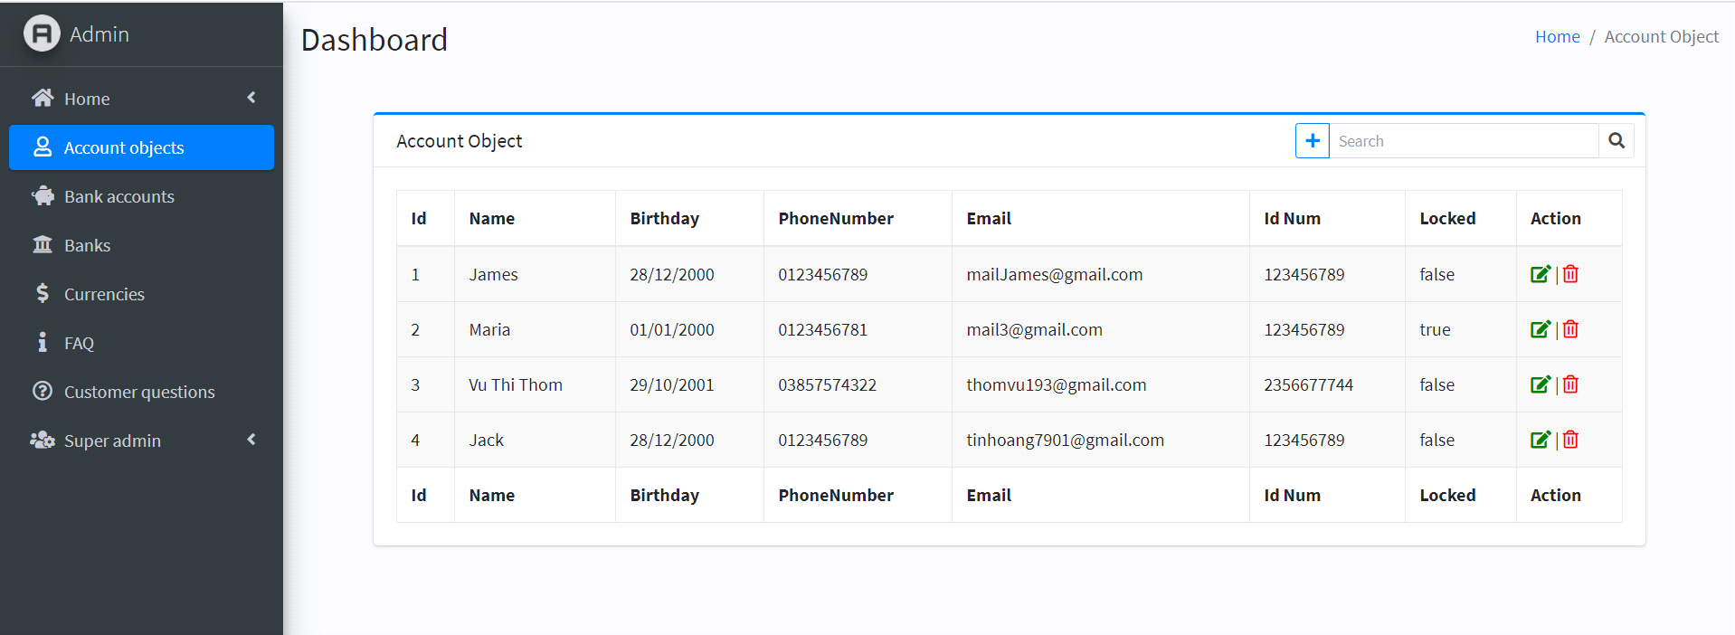

|  |  |
| --- | --- |
| **Operation No.** | **Description** |
| 1 | Show account information.  Searching for account information |

**3. Bank accounts page:**

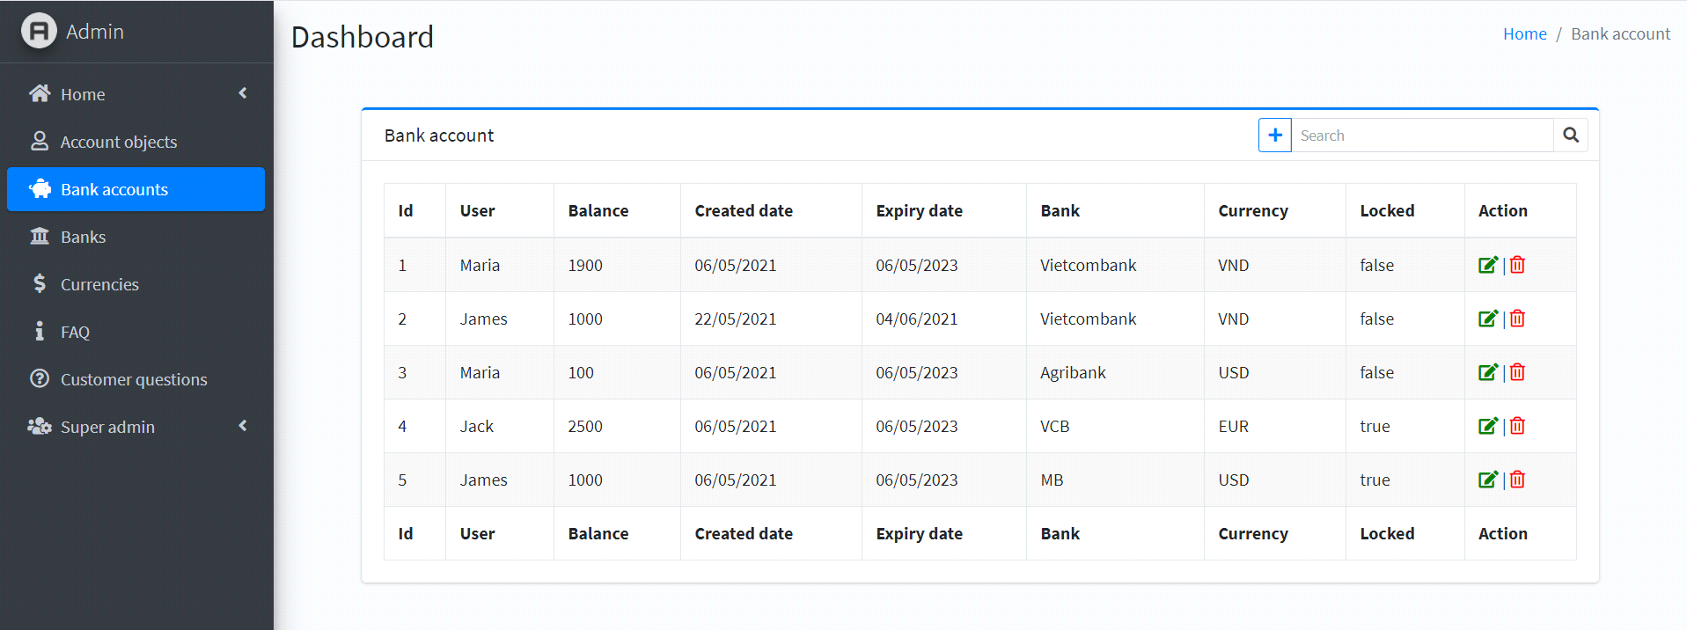

|  |  |
| --- | --- |
| **Operation No.** | **Description** |
| 1 | - Show account information   * Searching for account information * Edit Account * Delete Account * Block |

**4. Banks page:**

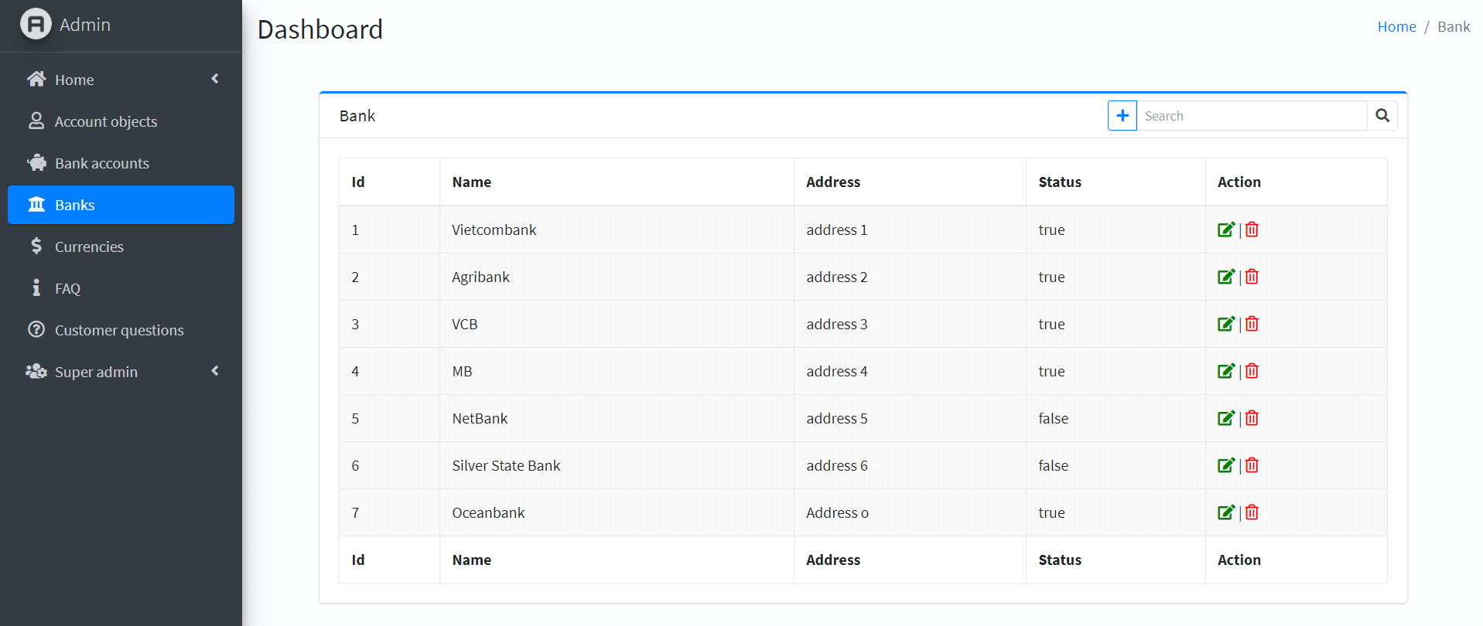

|  |  |
| --- | --- |
| **Operation No.** | **Description** |
| 1 | * Select a department in the table that you want to change name. |
| 2 | * Right-click to show the popup menu and choose the “Update” option and name of that department will be shown in the “Department name” field. |
| 3 | * Change as you need and click the “Update” button (please keep the “Finance Department” part) * Click the “Reset” button to reset all to default. |

5. **Curencies page:**



|  |  |
| --- | --- |
| **Operation No.** | **Description** |
| Currencies | * Show the list of users using which bank |
|  | * Click on delete or edit icon to change user information. * Users can enter keywords to find detailed personal information |

**6. FAQ page:**



|  |  |
| --- | --- |
| **Operation No.** | **Description** |
| 1 | Some essential questions to answer user questions |

1. **Cutomer questons page:**



|  |  |
| --- | --- |
| **Operation No.** | **Description** |
| Customer question | * Interface to answer questions from users |

1. **Super admin page:**

**A. Setting**



|  |  |
| --- | --- |
| Fields | Description |
| Setting | * Edit Title * Limit the number of posts displayed. * Default currency |

**B. Staff**



|  |  |
| --- | --- |
| **Operation No.** | **Description** |
| 1 | * Select a loan type in the table that you want to change name. |
| 2 | * Right-click to show the popup menu and choose the “Update” option and details of that loan type will be shown in acorrding fields. |
| 3 | * Change as you need and click the “Update” button (please keep the “ Loan” part) * Click the “Reset” button to reset all to default. |

**C.Help info**





|  |  |
| --- | --- |
| Fields | Description |
| Help Infor | * Change personal information Super Admin |
| Change Email Password | * Change the password |

Chapter VII: Developer guide

* Install Microsoft SQL Server Management
* Start and create database:
* On Microsoft SQL Server Management, right click “Database” 🡪 choose “New Database” 🡪 Fill in the “Database name” with “ProjectSemester” and click “OK”.

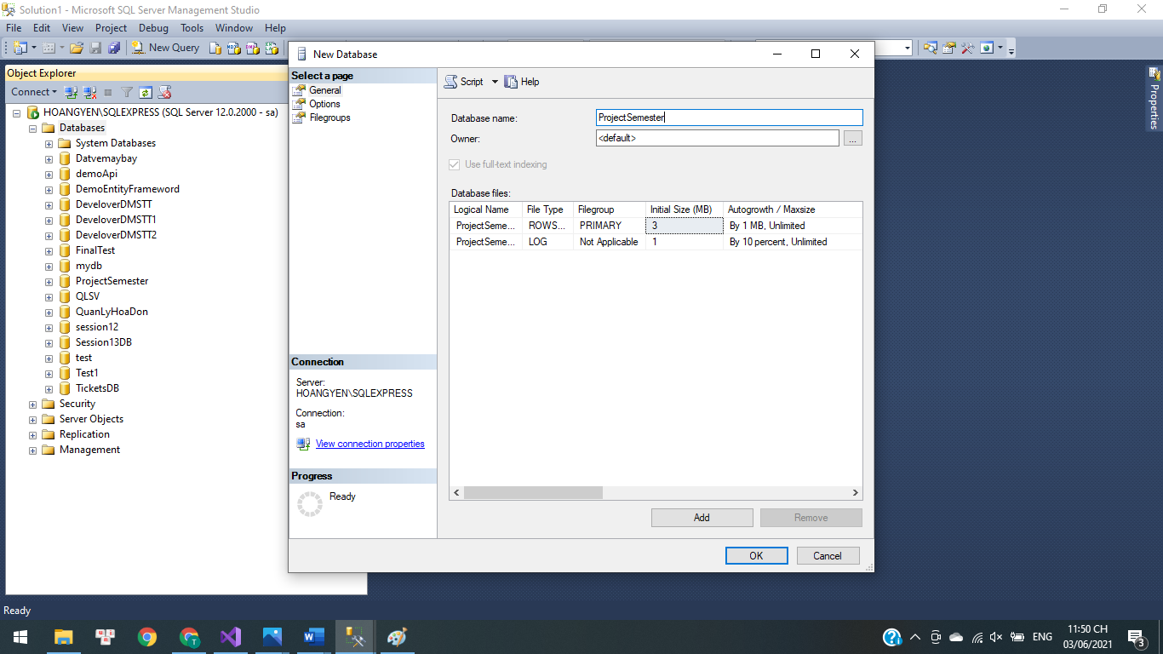

* After the database is created, choose “File”🡪 “Open” 🡪 “File” Choose the file “database.sql” and click “Open”.

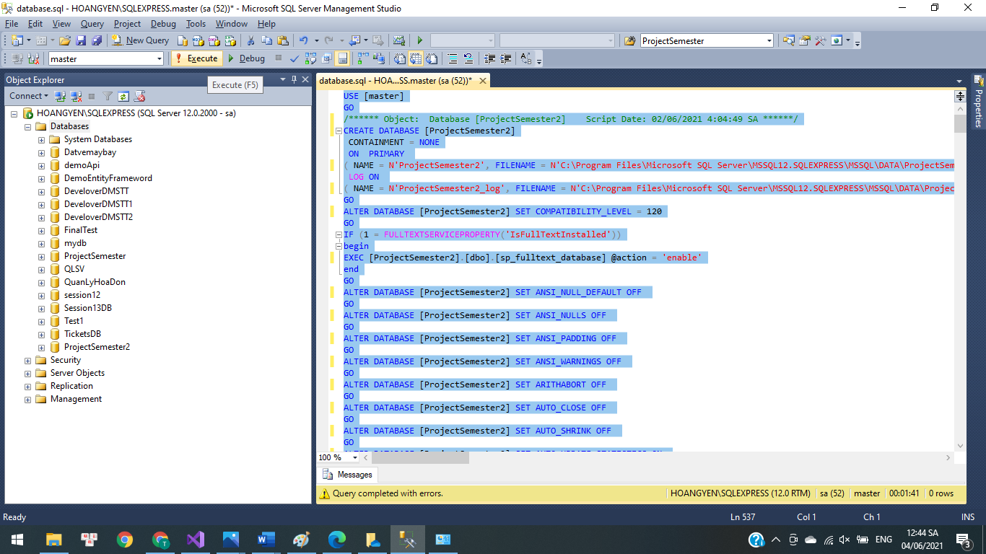

* Select all commands and press Execute. you have successfully imported the database.
* Change Server name:

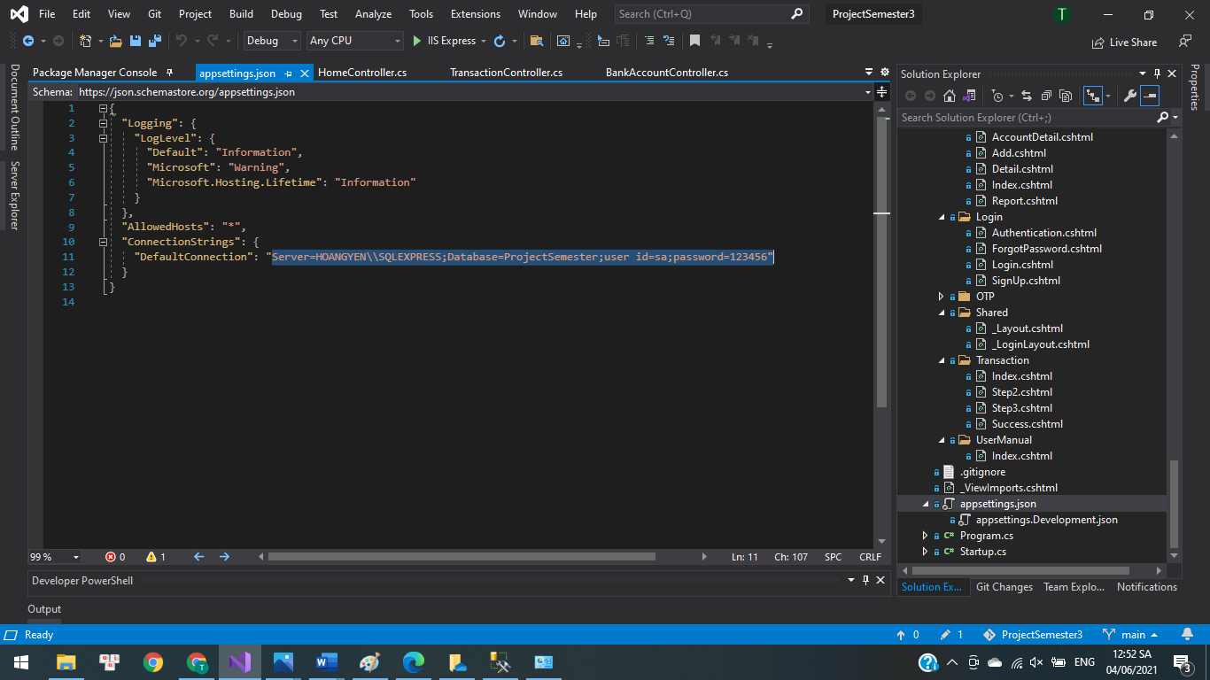

* Change the information to suit your computer:
* server: Server Name.
* id: id your Microsoft SQL Server Management account.
* password: password your Microsoft SQL Server Management account.
* Run application:
* Open “ProjectSemester3.sln” and below is the login screen.



* For user account:
* Username: username1
* Password: Ht792001@
* For admin account:
* Username: admin2
* Password: 123
* For super admin account:
* Username: superAdmin
* Password: 123

We sincerely thank you. We learned a lot during the project implementation.